**A**

**Project Report**

**On**

**“BRTS BUS PASS ONLINE REGISTRATION APP”**

**Prepared by**

JASH PASTAGIA(206120316046)

DHARMIK PATEL(206120316054)

VISHNU BURKHAWALA (206120316032)

**Under the Supervision of**

Mr. MANISH PATEL, HOD OF I.T.

**Submitted to**



**Information Technology Department**

**DR. S & S. S. GHANDHY COLLEGE OF ENGINEERING & TECHNOLOGY, SURAT**

**GUJARAT TECHNOLOGICAL UNIVERSITY**

**May 2023**



**CERTIFICATE**

This is to certify that project work embodied in this report entitled “**BRTS BUS PASS ONLINE REGISTRATION APP**” was carried out by **Jash Pastagia (206120316046),** **Dharmik Patel (206120316054)** and **Vishnu Burhkhawala (206120316032)** at **Dr. S & S. S. Ghandhy College of Engineering & Technology, Surat.**

For partial successful completion of **Project-II (3361606)** of **Semester-6** **Diploma engineering in Information Technology** to be awarded by Gujarat Technological University. This project work has been carried out under my supervision and is to the satisfaction of the department.

Date: Place: Surat

|  |  |
| --- | --- |
| Under the supervision of,  Mr. M.D. Patel  H.O.D., Information Technology Department  Dr. S. & S. S. Ghandhy College of Engineering & Technology, Surat | Mr. M.D. Patel  H.O.D., Information Technology Department  Dr. S. & S. S. Ghandhy College of Engineering & Technology, Surat |
| The Principal  Dr. S. & S. S. Ghandhy College of Engineering & Technology, Surat | External Examiner |

**DR. S. & S. S. GHANDHY COLLEGE OF ENGINEERING & TECHNOLOGY**

**INFORMATION TECHNOLOGY DEPARTMENT**

**Surat – 395001, Gujarat**

DECLARATION OF ORIGINALITY

We hereby certify that we are the sole author of this project and that neither any part of this work nor the whole work has been submitted for a degree to any other University or Institution.

We certify that, to the best of our knowledge, our work does not infringe upon anyone’s copyright nor violate any proprietary rights and that any ideas, techniques, quotation, or any other material from the work of other people included in our report or otherwise, are fully acknowledged in the accordance with the standard referencing practices.

We declare that this is a true copy our report, including any final revisions, as approved by our supervisor.

**Date:**

**Place:** Surat

**Yours Sincerely,**

Jash Pastagia (206120316046)

Dharmik Patel (206120316054)

Vishnu Burkhawala (206120316032)

ACKNOWLEDGEMENT

We are so glad to present our project report on **‘BRTS BUS PASS ONLINE REGISTRATION APP’**, which is prepared as a part of our final semester project in Diploma Engineering & Technology. This project work is the outcome of guidance provided by the dedicated Information Technology, Dr. S. & S. S. Ghandhy College of Engineering & Technology.

With a profound sense of indebtedness, we use this opportunity to express our sincere gratitude to Prof. Manish D Patel, H.O.D. of the Information Technology department for inspiring and permission to carry out our project.

We wish to extend our thanks to our project guide Prof. Manish D Patel, department of Information Technology for their keen interest, valuable guidance, and support rendered throughout our project.

Last but not least, thanks to **Dr. S. & S. S. Ghandhy College of Engineering & Technology** for providing us the platform to represent the project.

**Yours Sincerely,**

Jash Pastagia (206120316046)

Dharmik Patel (206120316054)

Vishnu Burkhawala (206120316032)

**Abstract**

* The BRTS BUS PASS ONLINE REGISTRATION APP is an android application that provides interface for user to apply for bus pass on their android device online.
* The Main Goal of this app is to provide convenience of user by reducing the trouble of waiting in a long queue and struggle of visiting the office persistently.
* This application is developed specially for the user who need to apply for a new bus pass. The user may be anyone who need a new bus pass including student, employee, professionals etc.
* We will also develop online portal for admin and verifier that works on web browser.
* This online portal supports admin and verifier to relief of controlling the long queue and managing paper works offline.

**PROJECT PROFILE:**

**Project Title:** BRTS BUS PASS ONLINE REGISTRATION APP

**Project Type:** Android Mobile Application

**Front-End:** Android Studio 2022.1.1 (Java)

**Operating System:** For Mobile Device: - Android 6 or above

For Website: - Windows 7.0 or above

**Back-side Language:** PHP 8.2.2 (MYSQL 8.0.33 AND FIREBASE 12.1.0)

**Project Guide:** Mr. Manish Patel

**Submitted By:** Jash Pastagia (206120316046), Dharmik Patel (20612036054),

Vishnu Burhkawala(206120316032)

**Submitted To:** Dr. S & S.S. Ghandhy College of Engineering & Technology, Surat

Table of Contents

**Declaration of Originality I**

**Acknowledgement II**

**Abstract III**

**Project Profile IV**

**Chapter-1 Introduction1**

1.1 Project definition 2

1.2 Scope of the project 3

**Chapter-2 System Requirement study** **4**

2.1 Problem of existing system 5

2.2 Requirement of proposed system 6

2.3 Project Life Cycle Model 7

2.4 Software Requirement Specification 9

**Chapter-3 System Design17**

3.1 ER Diagram 18

3.2 Data Flow Diagram 19

3.3 Data Dictionary 23

**Chapter-4 UML 26**

4.1 Use case Diagram 27

4.2 Activity Diagram 28

**Chapter-5 GUI/Application Interface 31**

5.1 UI for BRTS BUS REGISTRATION APPLICATION 32

5.2 UI for ADMIN Website 39

5.3 UI for VERIFIER Website 45

**Chapter-6 Testing 47**

6.1 User Side 48

6.2 Admin Side 54

6.3 Verifier Side 60

**Chapter-7 Advantages, Limitations & Future Enhancement 64**

**Chapter-8 Conclusion 67**

**Bibliography 69**

List of Figures

Fig 2.1 Project Life Cycle Model 7

Fig 3.1 Proposed System E-R Diagram 18

Fig 3.2 Basic Structure of DFD 20

Fig 3.3 Context Level Diagram21

Fig 3.4 Level-1 Data flow Diagram22

Fig 4.1 Use Case Diagram27

Fig 4.2 Use case symbol27

Fig 4.3 Activity Diagram for User 28

Fig 4.4 Activity Diagram for Admin 29

Fig 4.5 Activity Diagram for verifier officer 30

List of Tables

Table 3.1 u_detail 23

Table 3.2 u_comon_doc24

Table 3.3 u_s_doc 24

Table 3.4 u_h_doc 25

Table 3.5 a_login 25

Table 3.6 v_login25

Table 6.1 Test Case for User Side 48

Table 6.2 Test Case for Admin Side54

Table 6.3 Test Case for Verifier Side 60

**Chapter-1 Introduction**

**1.1 PROJECT DEFINITION**

BRTS BUS PASS ONLINE REGISTRATION APP is an Android application, in which Customer can interact with this application and request for creating a new Bus Pass.

Customer have to upload the documents which are required for Bus pass and after online verification user gets message to select a slot for verification of their identity to the BRTS office.

The front-end is our application is based on Android (java) and back-end of our application is based on Mysql using php.

**1.2 SCOPE OF THE PROJECT**

The purpose of the BRTS BUSS PASS ONLINE REGISTRATION APP is to obtain a new bus pass for user, who needs to get new bus pass to travel in the BRTS bus.

It reduces the effort from both side user as well as administration by forming whole the process online. It has three views.

1. Admin
2. Verifier officer
3. User

User has to upload their documents online through the application rather than visiting the office persistently for confirmation about their bus pass. Also, user avoids standing in a long queue for submitting the documents offline.

Admin is responsible for allocating an ID and password to the verifier officer. Admin uses online portal for verifying the Documents, which were uploaded by user on android application and gives permission to user for slot booking for one-time offline verification and identification of user, which is done by verifier officer. It reduces the effort to controlling the long queue and complexity in managing the paper works by admin in offline.

Verifier officer can login in the web portal using their ID and password

allocated by the admin. Verifier officer verifies the user’s identity, when user visits office as per slot allocation and officer gives conformation to user that it is eligible or not for bus pass. It reduces the effort to controlling the long queue and complexity in managing the paper works by verifier officer in offline.

After accomplished all the process of verification of documents and identification of user, user will get bus pass by home delivery.

**Chapter-2**

**System Requirement Study**

**2.1 PROBLEM OF EXISTING SYSTEM**

The main problem in an existing system is that to manage bunch of paper works. User have to fill up the form for requesting a bus pass and verifier have to collect both form and required documents with user’s photos and signature, which are stored in specific place for further process. But it will be burdensome when any employees need to fetch the data.

Another problem is that user(travellers) needs to stand in a long queue for submitting a form and verification of documents. This is inconvenient for user(travellers).

User's comfort is to get bus pass with less trouble. But the next problem states that the user need to visit the BRTS office persistently. That is, after document verification user needs to visit the BRTS office persistently for taking inquiry about their bus pass.

In this system process there is no mechanism to manage the confidentiality of the user data in form of documents.

**2.2 REQUIREMENT OF PROPOSED SYSTEM**

After analyzing the problem of the existing system, we are trying to fix it in BRTS BUSS PASS ONLINE REGISTRATION APPLICATION.

Form and required documents are uploaded online on this application so the fetching of data can be done easily. The trouble for user of standing in long queue can also be solved by application.

Admin and verifier use web portal to verify the documents and identity. Admin verifies the documents which were uploaded by user and gives permission for slot booking for verification of identity. So, Admin and verifier no need to manage the bunch of paperwork’s and long queue.

Also, by this online proposed system, user no needs to visit the office persistently. Only needs to visit the office once for verification of identity and get their bus pass by home delivery.

In existing system process there is no mechanism to manage the confidentiality of the user data in form of documents. But we are providing dexterously security mechanism, so user data in form of documents will be secured.

**2.3 PROJECT LIFE CYCLE MODEL**

**Iterative Waterfall Model :-**

The waterfall model is a popular version of the system develop life cycle model for software engineering.

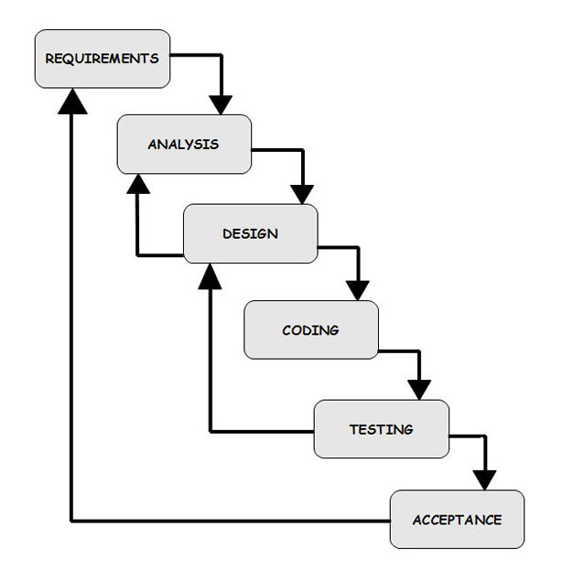 The waterfall model describes a development method that is linear and sequential. It is also known as linear and sequential model.

**Fig 2.1 Project Life Cycle Model**

Waterfall development has distinct goals for each phase of development. Imagination a waterfall on the cliff of a steep mountain. Once the water has flowed over the edge of the cliff and begun. Its journey down the mountain, it cannot turn back. It is same with waterfall development is completed the development proceeds to the next phase and there is turning back.

The simplest software development life cycle model is the waterfall model. A project begins states with feasibility analysis.

The design starts after the requirements analysis is done and coding begins after the design is done. Once the programming is completed, the code is integrated after this the regular operations and maintenance of the system takes place. The following figure demonstrates the steps involved in waterfall life cycle model.

The disadvantage of waterfall development is that it does not allow for much reflection or revision.

**Advantages:**

* Easy to explain to the user and very simple model to implement.
* Stages and activities are scheduled the defined.
* Helps to plan and schedule the project.

**2.4 SOFTWARE REQUIREMENT SPECIFICATION (SRS)**

**Requirements:**

There are two types of Requirement :-

1. Functional analysis.
2. Non- Functional analysis.

* **Functional analysis:**

BRTS BUSS PASS ONLINE REGISTRATION APPLICATION is categorized into two main platforms :-

* Android Application (For Users)
* Web Portal (For Admin/Verifier Officer)
* **Android Application (For Users)**

Android Application is an Android application which have following modules :-

* Login Module
* Sign up Module
* Form Fill Up Module
* Upload Document Module
* Upload Photo/Signature Module
* Slot Booking
* Status Of Bus Pass
* **Web Portal (For Admin/Verifier Officer)**

Web Portal is a web application which have following modules :-

* Selection Module

More module are divided into two views :-

* **Admin’s view :-**
* Login Module
* Document Verification Module
* Status Module
* **Verifier Officer’s view :-**
* Login Module
* Identity Verification Module
* Status Module
* **Android Application (For Users)**

Android Application used by an user for requesting of bus pass. In which application is fully based on the Android platform (language JAVA) and that is connected with MYSQL database.

1. **Login Module**

* User who has already signed up can login into application.
* User needs to login through their Username and Password if they have already Signed up into application.

**Details required for Log In:**

* Username : User has their unique username which was decided by them at time of sign up.
* Password : User has decided their password at the time of sign up which are sequence of characters and numbers.
* Forget Password : User who has forget their password and want to reset their password can use this functional requirement.

1. **Sign up Module**

* New user who want to issue their bus pass can do registration for Log- in to this application.

**Details required for sign up:**

* Create Username : User needs to create their unique Username.
* Password : User needs to create their strong password by using the combinations of characters and numbers.
* Confirm Password : User needs to re-enter the password for confirmation of password.
* Email ID : User needs to enter their Email ID for verification of their Identity.

1. **Form Fill Up Module**

* After log in user has to request for the bus pass by filling their details in the form.

**Details required for filling the form:**

* Firstname : User has to enter their name.
* Lastname : User has to enter their surname.
* Phone number : User has to enter their Number.
* Gender : User has to choose their Gender.

i.e. Male, Female, Others.

* Date Of Birth : User has to select their Birth Date.
* Landmark : User has to enter their Landmark.
* Address : User has to enter their Address.
* City : User has to select their City.
* Email : User has to enter has their Email ID.
* Pin Code : User has to enter their Pin Code of the area.
* Category : User has to choose their Category.

i.e. Student, Citizen, Senior Citizen, Handicap.

1. **Upload Document Module**

* After Filling The Form, User has to Upload their document according to their category.

**Details required for uploading Documents:**

* Common Documents
* Aadhar Card : User has to upload their aadhar card in the pdf format, size of the pdf must be less then 100kb.
* Electricity Bill : User has to upload the electricity bill in pdf format in which current address of user is necessary.
* Photo : User has to upload their latest photo in png, jpeg, jpg, size of the pdf must be less then 100kb.
* Signature : User has to upload their latest photo of their signature in png, jpeg, jpg, size of the pdf must be less then 100kb.
* Student Documents
* Bonafide Certificate : Student has to upload a bonafide certificate which is officially given by school or college.
* Citizen Documents
* Is user a Senior Citizen : According to their Date Of Birth, It is confirmed that the user is Citizen or Senior Citizen.
* Handicap Documents
* Disability Certificate : Handicap User has to upload their Disability Certificate in the pdf format, size of the pdf must be less than 100 kb.

1. **Slot Booking**

* After Uploading Documents, Admin will verify the Documents of user and then user can book their slot for visiting the office for verification of their identity.

**Details required for Slot Booking:**

* Time Slot : User Has To select the time slot according to their convenience for visiting to the office.

1. **Status Of Bus Pass**

* At any point in the process of bus pass user can check their current status.

**Details displayed in Status:**

* Submit Date : Date when user has requested for the new buss pass.
* Verified Date : Date when documents are verified by the admin.
* Time Slot : Date And Time which was selected by user at Slot Booking.
* Verified Status : Status that the user is eligible for bus pass or not.
* **Web Portal (For Admin/Verifier Officer)**

Web Portal used by an Admin and Verifier Officer. Admin used for verification of personal details and documents uploaded by user. Verifier Officer used for verification of identity in offline mode. Verifier Officer gets details about list of users who are going to visit the office at that day for verification of identity. Web Portal is based on the HTML, CSS and PHP that is connected with MYSQL database.

* **Selection Module**
* First of all, it needs to specify that the person is Admin or Verifier Officer.
* By Selection Module they can select whether person is Admin or Verifier Officer.
* By choosing they can be redirect to Admin’s View or Verifier Officer’s View according their choice.
* **Admin’s view :-**

1. **Login Module**

* Admin needs to Enter their Username and Password for Log into the web portal.

**Details required for Log In:**

* Username : Admin has their unique username which was given to them by any authorized person.
* Password : Admin has their password which was given to them by any authorized person.

1. **Document Verification Module**

* Admin has to verify the personal information of user and documents which user uploads.
* Admin thoroughly checks the personal information and documents and gives status about documents.
* Status can be Yes or No. If Yes, then that document is successfully verified. If No, then user need to re-upload documents.

**Details displayed in Document Verification:**

* Verified Status : Admin will give status for personal information and documents that they are genuine or not.

1. **Status Module**

* Admin verifies all the documents and decides if they are genuine or not.
* Result of all documents status will be displayed in this Status Module.

**Details displayed in Status Module:**

* Personal Information : Personal Information of user is displayed i.e. Name, Phone No., etc.
* Verified Status : Admin will give status for personal information and documents that they are genuine or not.
* **Verifier Officer’s view :-**

1. **Login Module**

* Verifier Officer needs to Enter their Username and Password for Log into the web portal.
* Username and Password are given by Admin.
* If they Forget their Username and Password, Admin can reset Username or Password for them.

**Details required for Log In:**

* Username : Verifier Officer has their unique username which was given to them by Admin.
* Password : Admin has their password which was given to them by Admin.

1. **Identity Verification Module**

* Verifier Officer has to verify the identity of user and documents in offline mode.
* Verifier Officer thoroughly checks the identity and documents and gives status.
* Status can be Yes or No. If Yes, then user can get bus pass by home delivery. If No, then user need to re-verify.

**Details displayed in Identity Verification:**

* Verified Status : Verifier Officer will give status for verification of identity and documents of user in offline mode and checks whether the user is genuine or not.

1. **Status Module**

* Verifier Officer verifies identity of user and decides if user is genuine or not.
* Result of all user status will be displayed in this Status Module.

**Details displayed in Status Module:**

* Personal Information : Personal Information of user is displayed i.e. Name, Phone No., etc.
* Verified Status : Verifier Officer will give status for verification of identity and documents of user in offline mode and checks whether the user is genuine or not.
* **Non-Functional analysis:**
* **Security:**
* Security is required so that no personal information of user is leaked and the data of system can’t be steal.
* **Atomicity:**
* Unauthorized people can’t operate this application.
* **Reliability:**
* Reliability stands for trust. User’s personal information will not be disclosed here.
* **Flexibility:**
* Application is flexible to open in any Android phone.
* **Efficiency:**
* User can easily get Bus Pass Online and need not to stand in long queue.
* **Integrity:**
* Only the system admin has the right to access the database, verifier officer and user will only have access to their account.

**Chapter-3**

**System Design**

**3.1 ENTITY RELATIONSHIP DIAGRAM (ERD)**

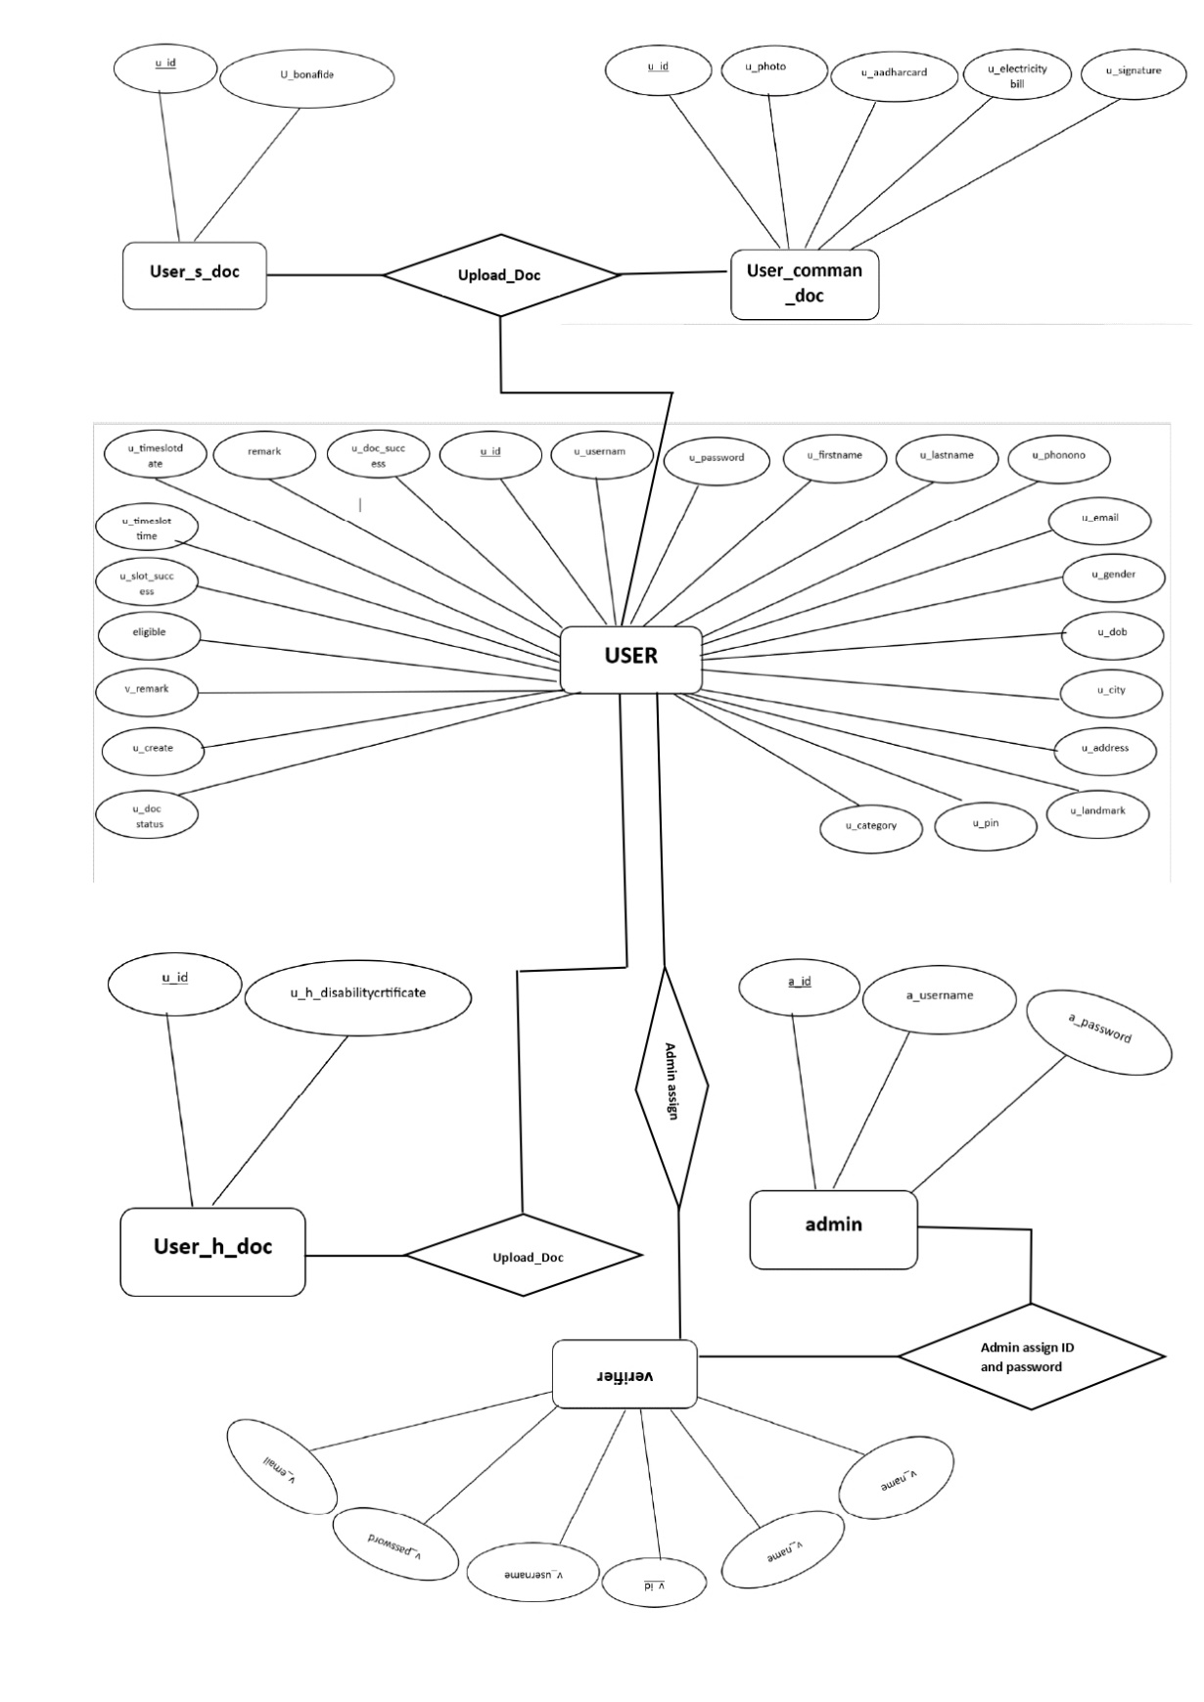

**Fig 3.1 Proposed System E-R Diagram**

**3.2 DATA FLOW DIAGRAM (DFD)**

DFD is the abbreviation for Data Flow Diagram. The flow of data of a system or a process is represented by DFD. It also gives insight into the inputs and outputs of each entity and the process itself. DFD does not have control flow and no loops or decision rules are present. Specific operations depending on the type of data can be explained by a flowchart. Data Flow Diagram can be represented in several ways. The DFD belongs to structured-analysis modeling tools. Data Flow diagrams are very popular because they help us to visualize the major steps and data involved in software-system processes.

**Components of DFD**

The Data Flow Diagram has 4 components:

**Process**

Input to output transformation in a system takes place because of process function. The symbols of a process are rectangular with rounded corners, oval, rectangle or a circle. The process is named a short sentence, in one word or a phrase to express its essence

**Data Flow**

Data flow describes the information transferring between different parts of the systems. The arrow symbol is the symbol of data flow. A relatable name should be given to the flow to determine the information which is being moved. Data flow also represents material along with information that is being moved. Material shifts are modeled in systems that are not merely informative. A given flow should only transfer a single type of information. The direction of flow is represented by the arrow which can also be bi-directional.

**Warehouse**

The data is stored in the warehouse for later use. Two horizontal lines represent the symbol of the store. The warehouse is simply not restricted to being a data file rather it can be anything like a folder with documents, an optical disc, a filing cabinet. The data warehouse can be viewed independent of its implementation. When the data flow from the warehouse it is considered as data reading and when data flows to the warehouse it is called data entry or data updating.

**Terminator**

The Terminator is an external entity that stands outside of the system and communicates with the system. It can be, for example, organizations like banks, groups of people like customers or different departments of the same organization, which is not a part of the model system and is an external entity. Modeled systems also communicate with terminator.

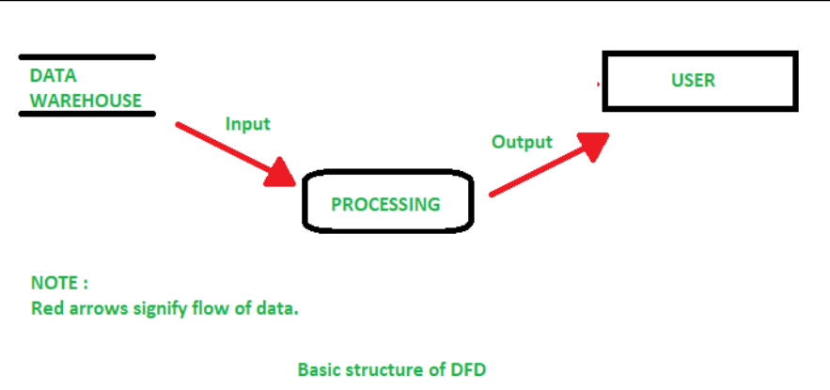

**Fig 3.2 Basic Structure of DFD**

**Level 0 DFD (Context Diagram)**

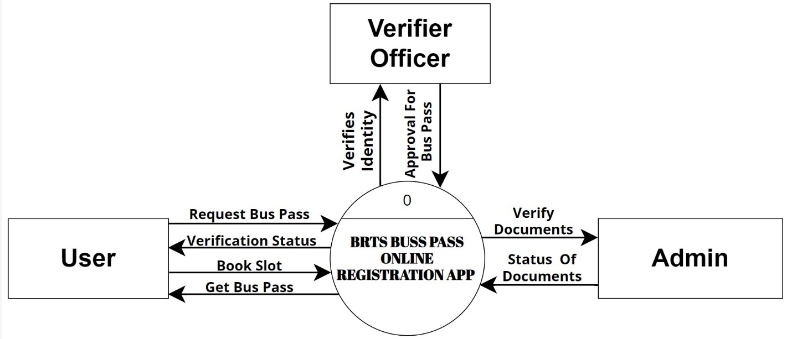

**Fig 3.3 Context Level Diagram**



**Level 1 DFD**

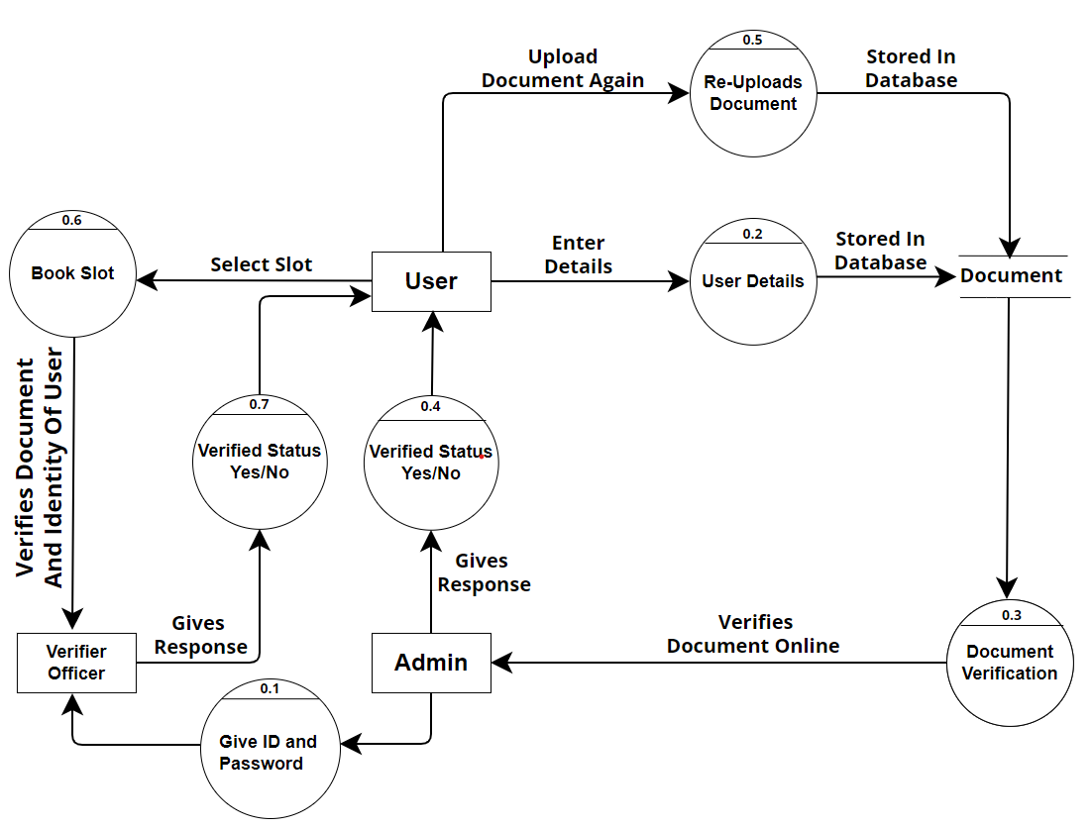

**Fig 3.4 Level-1 Data Flow Diagram**

**3.3 DATA DICTIONARY**

* **User(u_detail)**

|  |  |  |  |  |  |
| --- | --- | --- | --- | --- | --- |
| **Sr.**  **No.** | **Field Name** | **Data Type(Size)** | **Constraint** | **Default** | **Description** |
| 1 | u_id | int(10) | Primery key | Autoincrement | Id of a user |
| 2 | u_username | varchar(100) | UNIQUE | none | Username of a user |
| 3 | u_password | varchar(100) | NOTNULL | none | Password of a user |
| 4 | status | int(10) | NOTNULL | 1 | Status of a user identification |
| 5 | u_firstname | varchar(1000) | NOTNULL | none | First name of a user |
| 6 | u_lastname | varchar(1000) | NOTNULL | none | Last name of a user |
| 7 | u_phonenumber | varchar(1000) | NOTNULL | none | Phone number of a user |
| 8 | u_email | varchar(1000) | NOTNULL | none | Email of a user |
| 9 | u_gender | varchar(100) | NOTNULL | none | Gender of a user |
| 10 | u_dob | varchar(100) | NOTNULL | None | Birthdate of a user |
| 11 | u_city | varchar(100) | NOTNULL | None | Native city of a user |
| 12 | u_address | varchar(100) | NOTNULL | None | Address of a user |
| 13 | u_landmark | varchar(100) | NOTNULL | None | Landmark of a user |
| 14 | u_pin | varchar(100) | NOTNULL | none | Area pincode of a user |
| 15 | u_category | varchar(100) | NOTNULL | None | Indicates which category does the user belongs to |
| 16 | u_doc_success | int(10) | NOTNULL | none | User documentation |
| 17 | u_doc_status | int(10) | NOTNULL | 0 | Documentation is successful |
| 18 | remark | varchar(100) | NOTNULL | 0 | Remark of documentation |
| 19 | u_timeslotdate | date | NOTNULL | 0 | Date selected by user |
| 20 | u_timeslottime | varchar(100) | NOTNULL | 1000-01-01 | Timeslot selected by user |
| 21 | u_slot_success | int(11) | NOTNULL | 0 | Indicates whether the slot selection is successful |
| 22 | eligible | int(10) | NOTNULL | 0 | Eligibility of a user to have a bus pass |
| 23 | v_remark | varchar(100) | NOTNULL | 0 | Remarks of verification |
| 24 | u_create | Int(100) | NOTNULL | 0 | Status of bus pass create or not |

**Table 3.1 u_detail**

* **User comman Document (u_comman_doc)**

|  |  |  |  |  |  |
| --- | --- | --- | --- | --- | --- |
| **Sr.**  **No.** | **Field Name** | **Data Type(Size)** | **Constraint** | **Default** | **Description** |
| 1 | u_id | int(10) | foreign key | none | Id of a user |
| 2 | u_photo | varchar(1000) | notnull | none | Photo of a user |
| 3 | u_aadharcard | varchar(1000) | notnull | none | Adharcard of a user |
| 4 | u_electricitybill | varchar(1000) | notnull | none | Electricity bill of a user |
| 5 | u_signature | varchar(1000) | notnull | none | Signature of a user |

**Table 3.2 u_comon_doc**

* **User student Document (u_s_doc)**

|  |  |  |  |  |  |
| --- | --- | --- | --- | --- | --- |
| **Sr.**  **No.** | **Field Name** | **Data Type(Size)** | **Constraint** | **Default** | **Description** |
| 1 | u_id | int(10) | foreign key | none | Id of user |
| 2 | u_bonafide | varchar(1000) | notnull | 0 | Bonafide of a user |

**Table 3.3 u_s_doc**

* **User Handicap Document (u_h_doc)**

|  |  |  |  |  |  |
| --- | --- | --- | --- | --- | --- |
| **Sr.**  **No.** | **Field Name** | **Data Type(Size)** | **Constraint** | **Default** | **Description** |
| 1 | u_id | int(10) | foreign key | none | Id of a user |
| 2 | u_h_disabilitycertificate | varchar(1000) | notnull | none | Disability certificate of a user |

**Table 3.4 u_h_doc**

* **Admin(a_login)**

|  |  |  |  |  |  |
| --- | --- | --- | --- | --- | --- |
| **Sr.**  **No.** | **Field Name** | **Data Type(Size)** | **Constraint** | **Default** | **Description** |
| 1 | a_id | int(10) | Primery key | none | Id of an admin |
| 2 | a_username | varchar(100) | UNIQUE | none | Username of an admin |
| 3 | a_password | varchar(100) | NOTNULL | none | Password of an admin |

**Table 3.5 a_login**

* **Verifier(v_login)**

|  |  |  |  |  |  |
| --- | --- | --- | --- | --- | --- |
| **Sr.**  **No.** | **Field Name** | **Data Type(Size)** | **Constraint** | **Default** | **Description** |
| 1 | v_id | int(10) | Primery key | autoincrement | Id of a verifier |
| 2 | v_name | varchar(1000) | NOTNULL | none | Name of a verifier |
| 3 | v_email | varchar(1000) | NOTNULL | none | Email of a verifier |
| 4 | v_username | varchar(1000) | NOTNULL | none | Username of a verifier |
| 5 | v_password | varchar(1000) | NOTNULL | none | Password of a verifier |
| 6 | v_branch | varchar(1000) | NOTNULL | none | Branch of a verifier |

**Table 3.6 v_login**

**Chapter-4**

**UML**

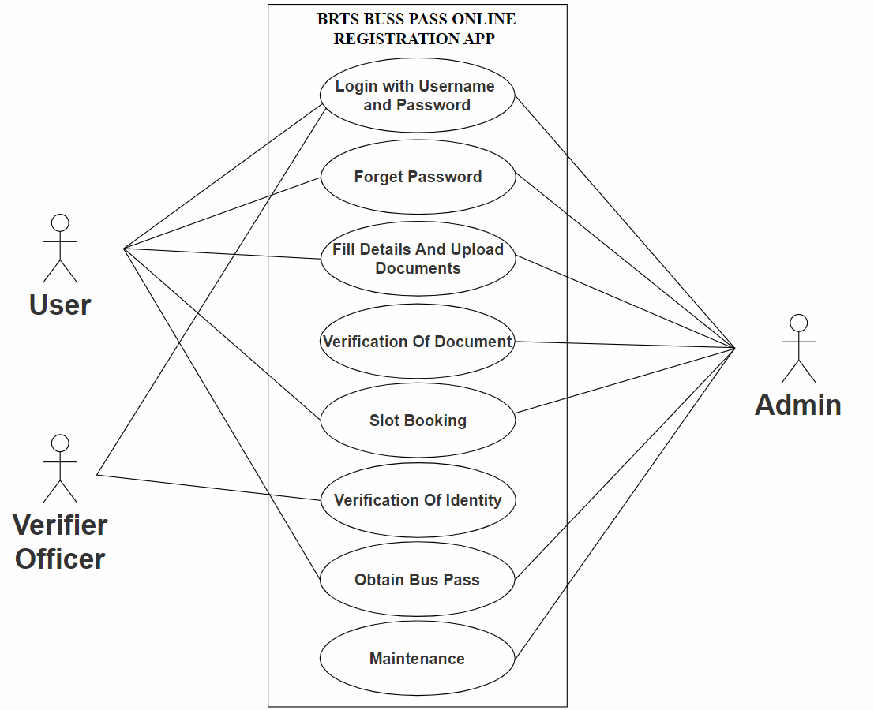**4.1 USE CASE DIAGRAM**

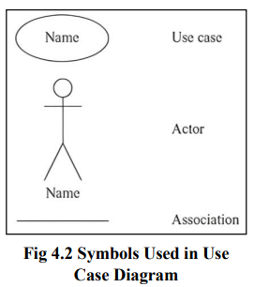

**Fig 4.1 Use Case Diagram**

**4.2 ACTIVITY DIAGRAM**

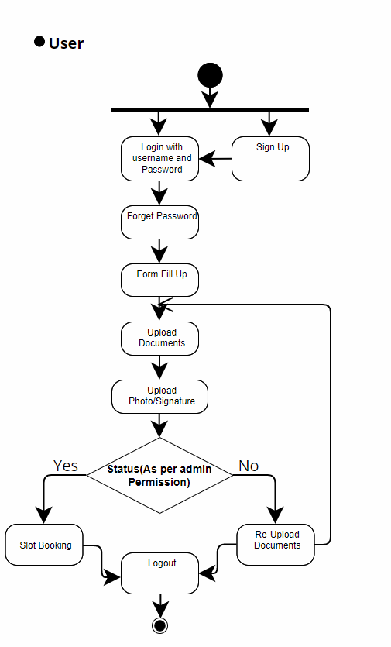

**Fig 4.3 Activity Diagram for User**

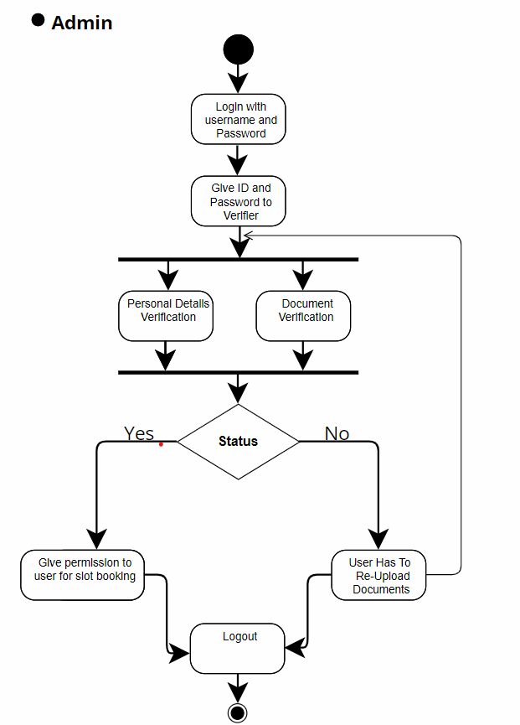

**Fig 4.4 Activity Diagram for Admin**

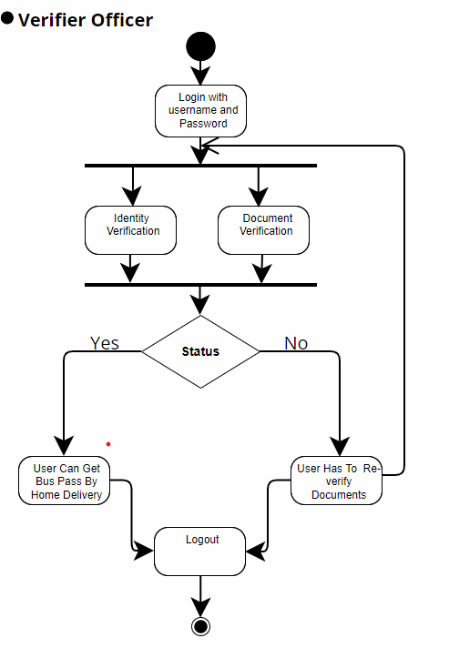

**Fig 4.5 Activity Diagram for Verifier Officer**

**Chapter-5**

**GUI/Application Interface**

**5.1 UI FOR BRTS BUS PASS REGISTRATION APPLICATION**



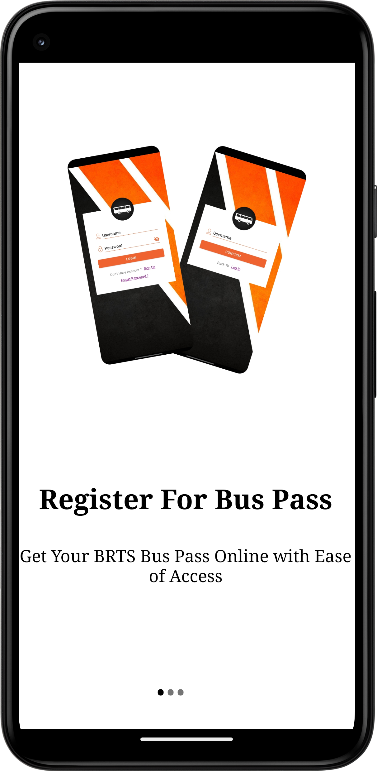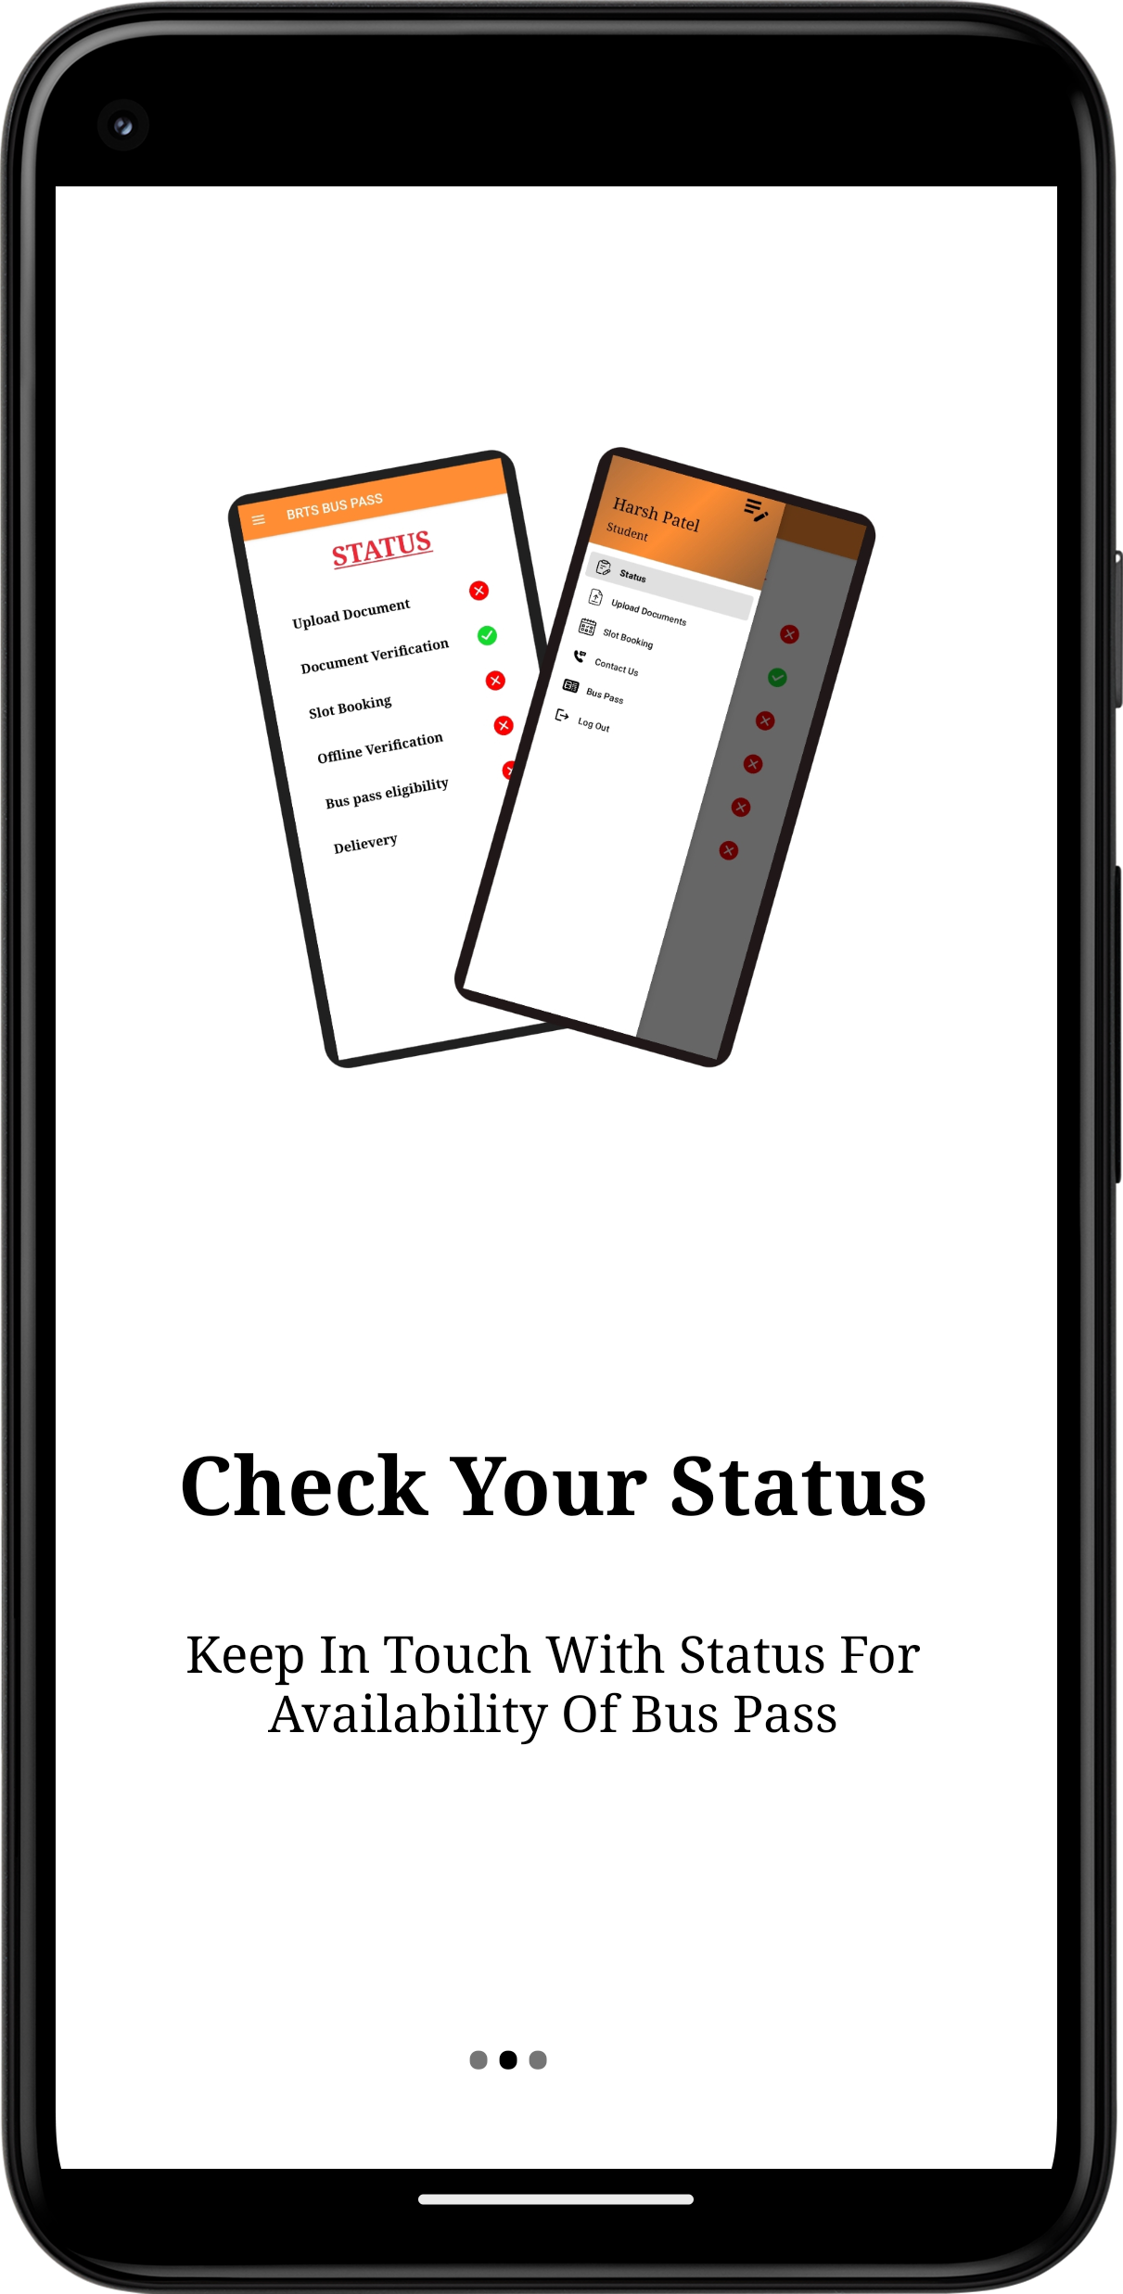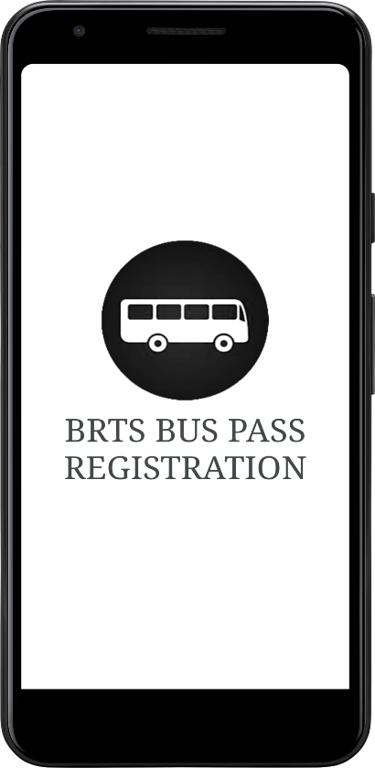 Splash/Welcome Screen Walkthrough - 1 Walkthrough - 2

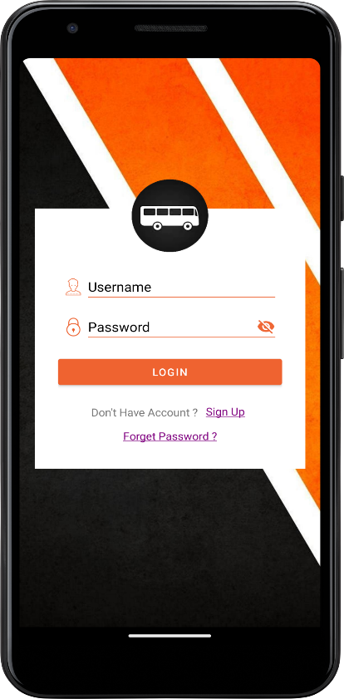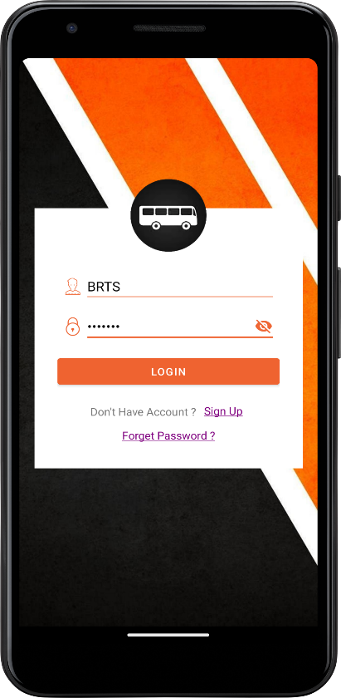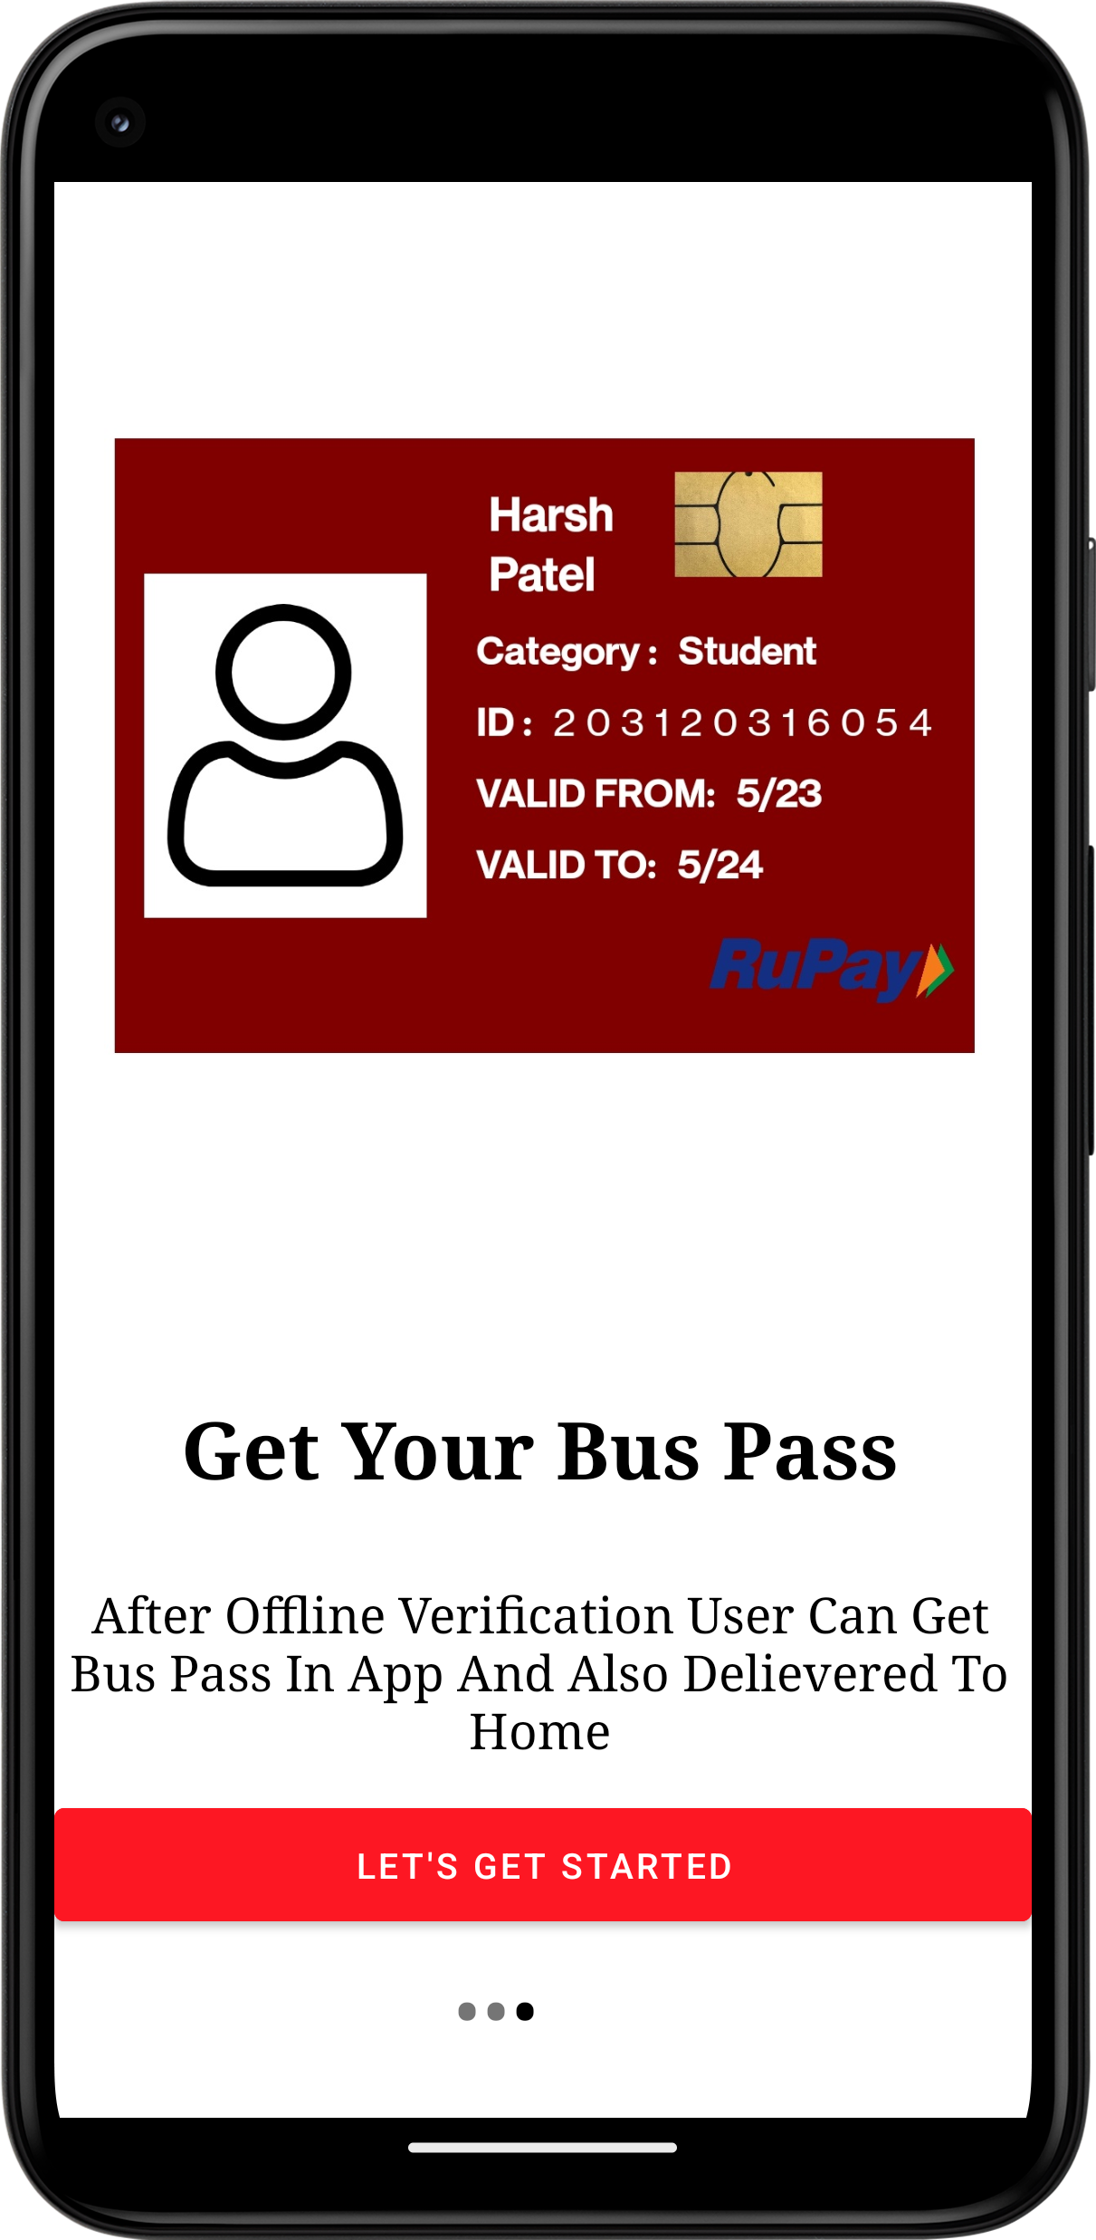 Walkthrough – 3 Log In Interface Log In (Password Invisible)

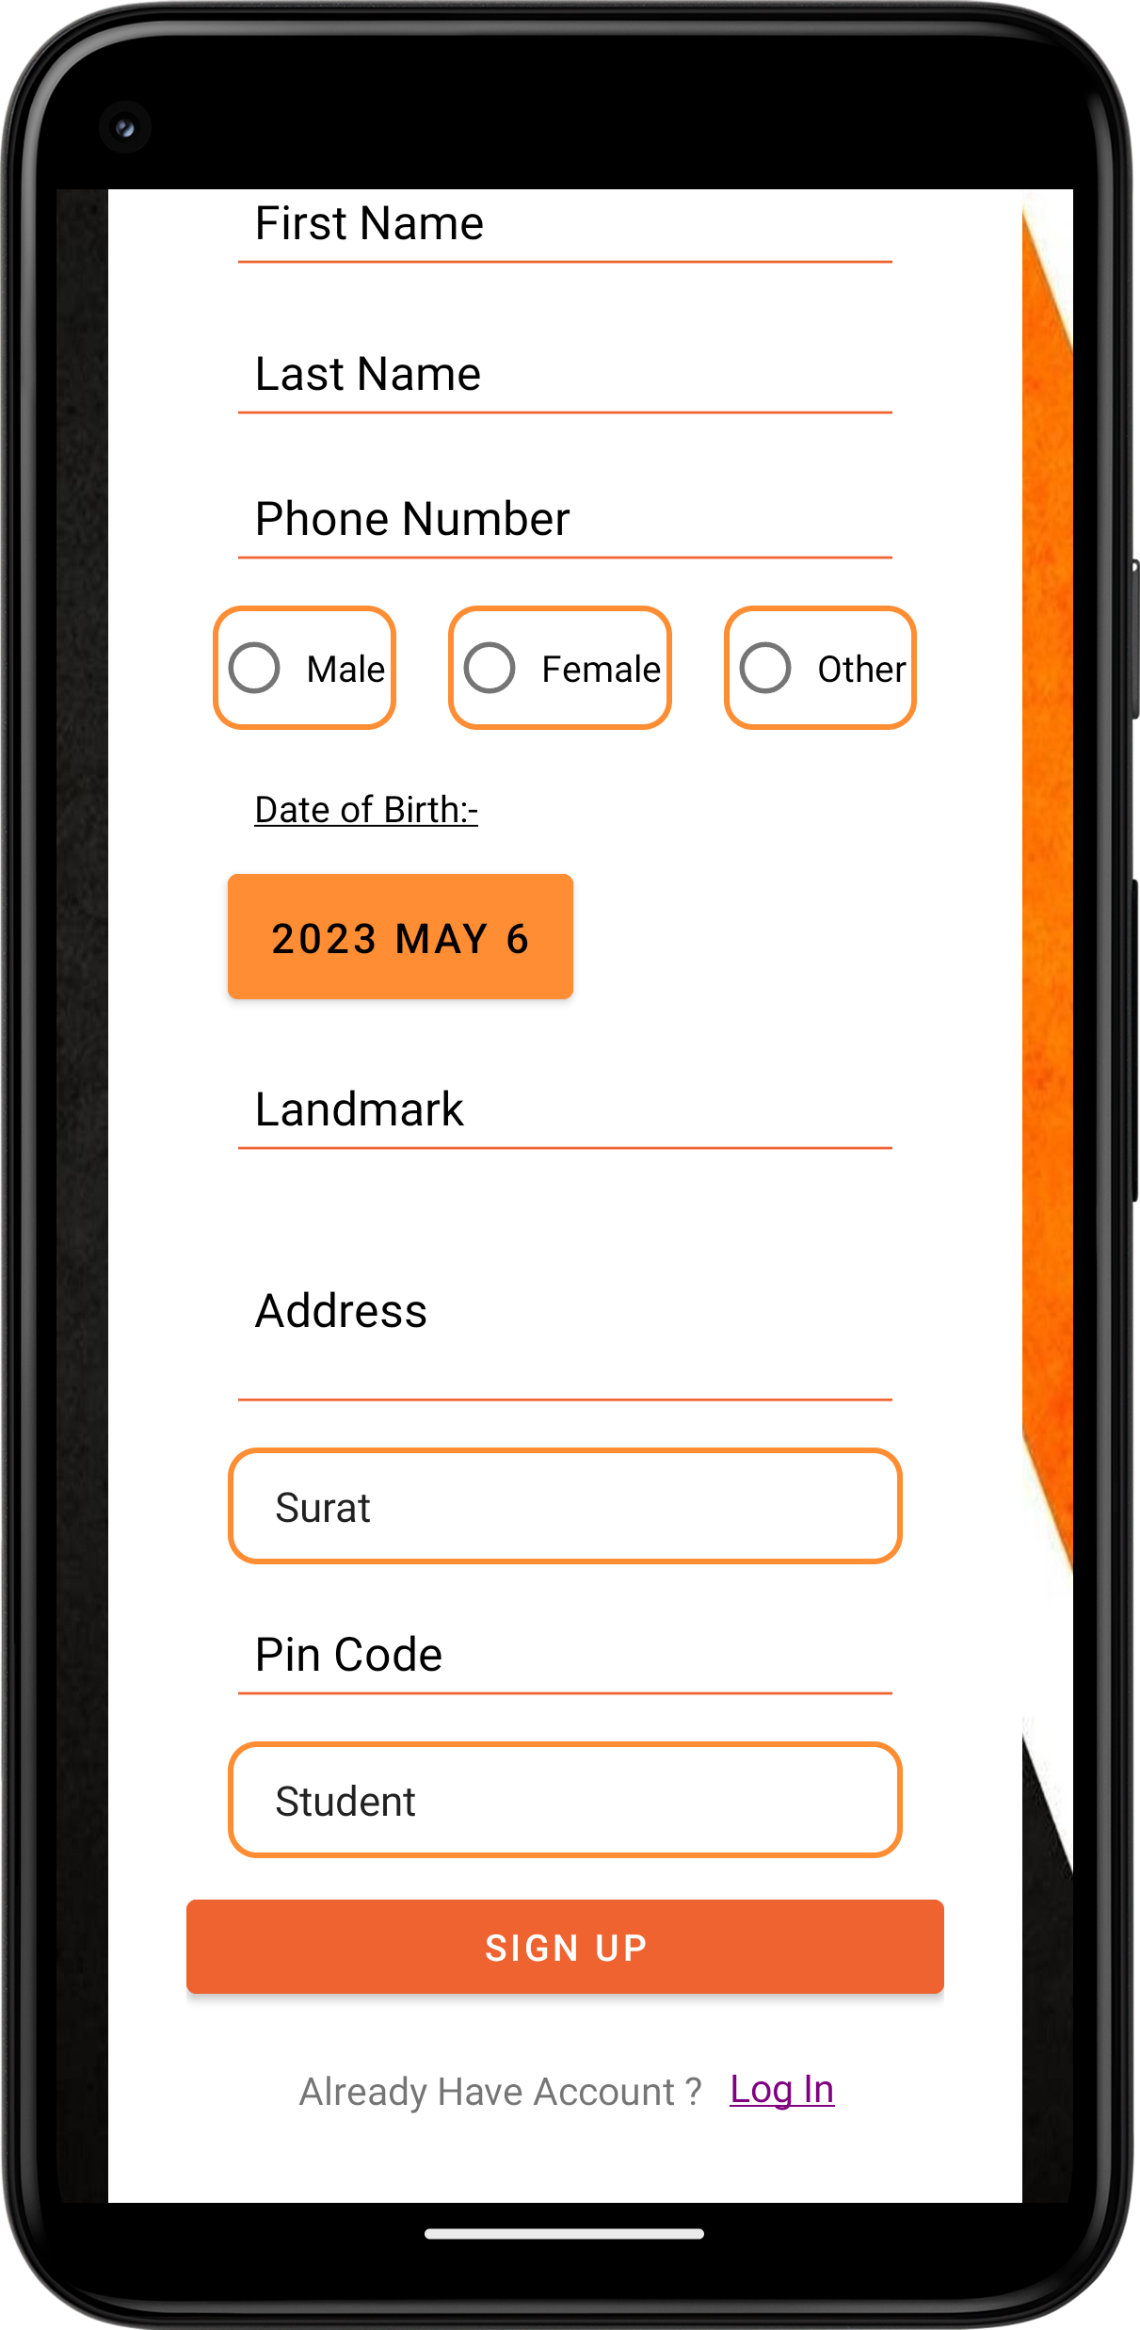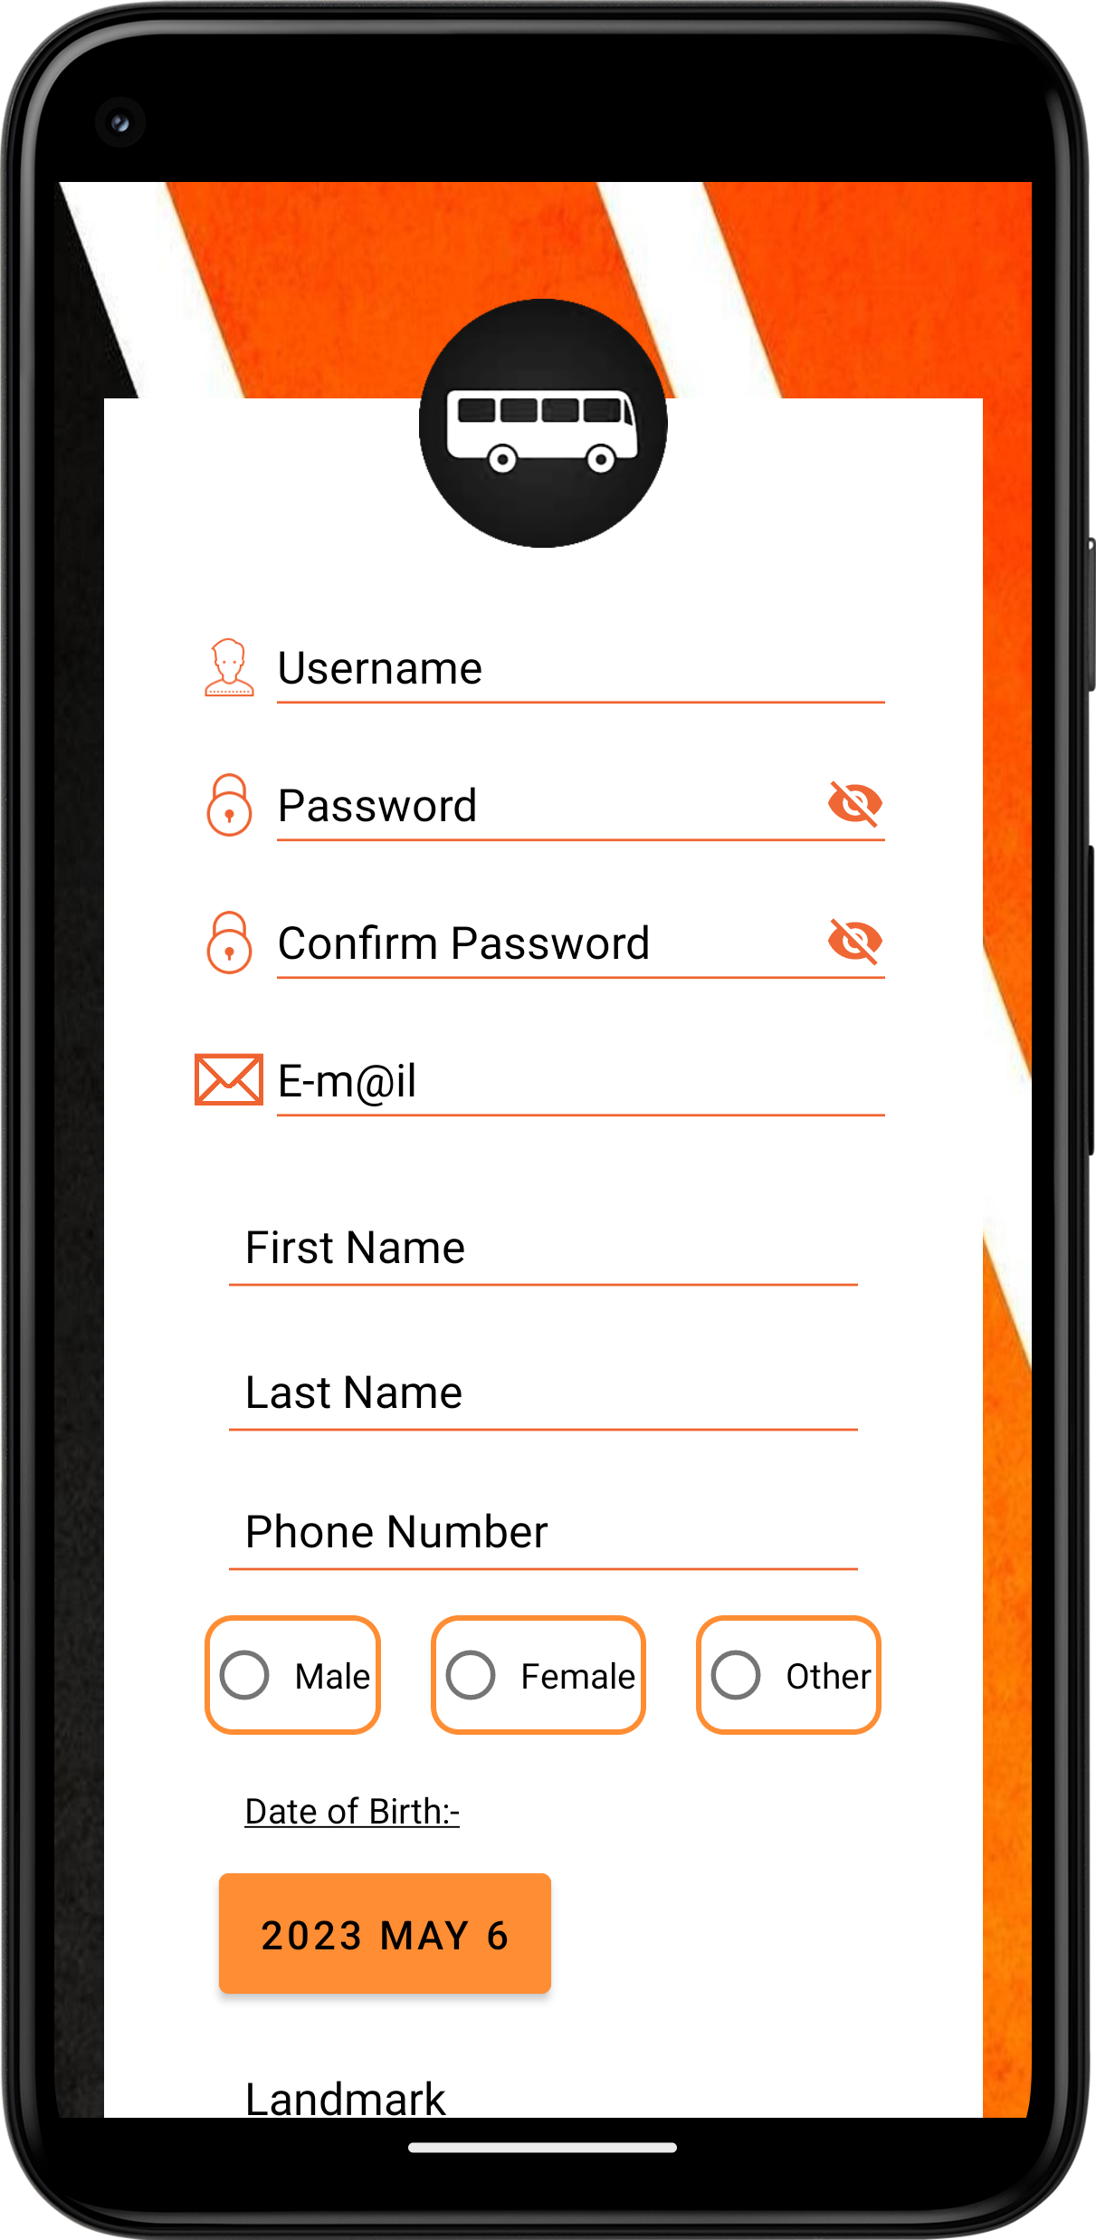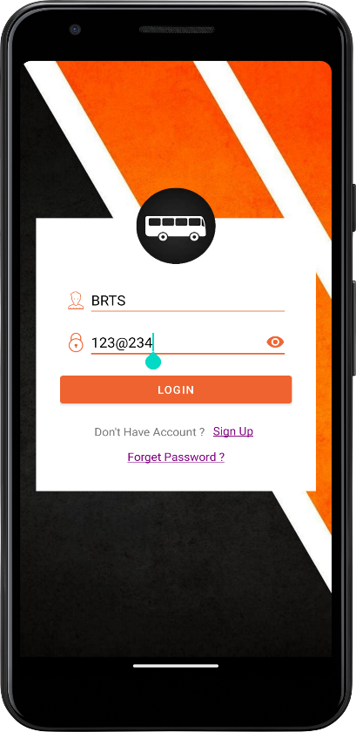Log In (Password Visible) Sign Up Interface

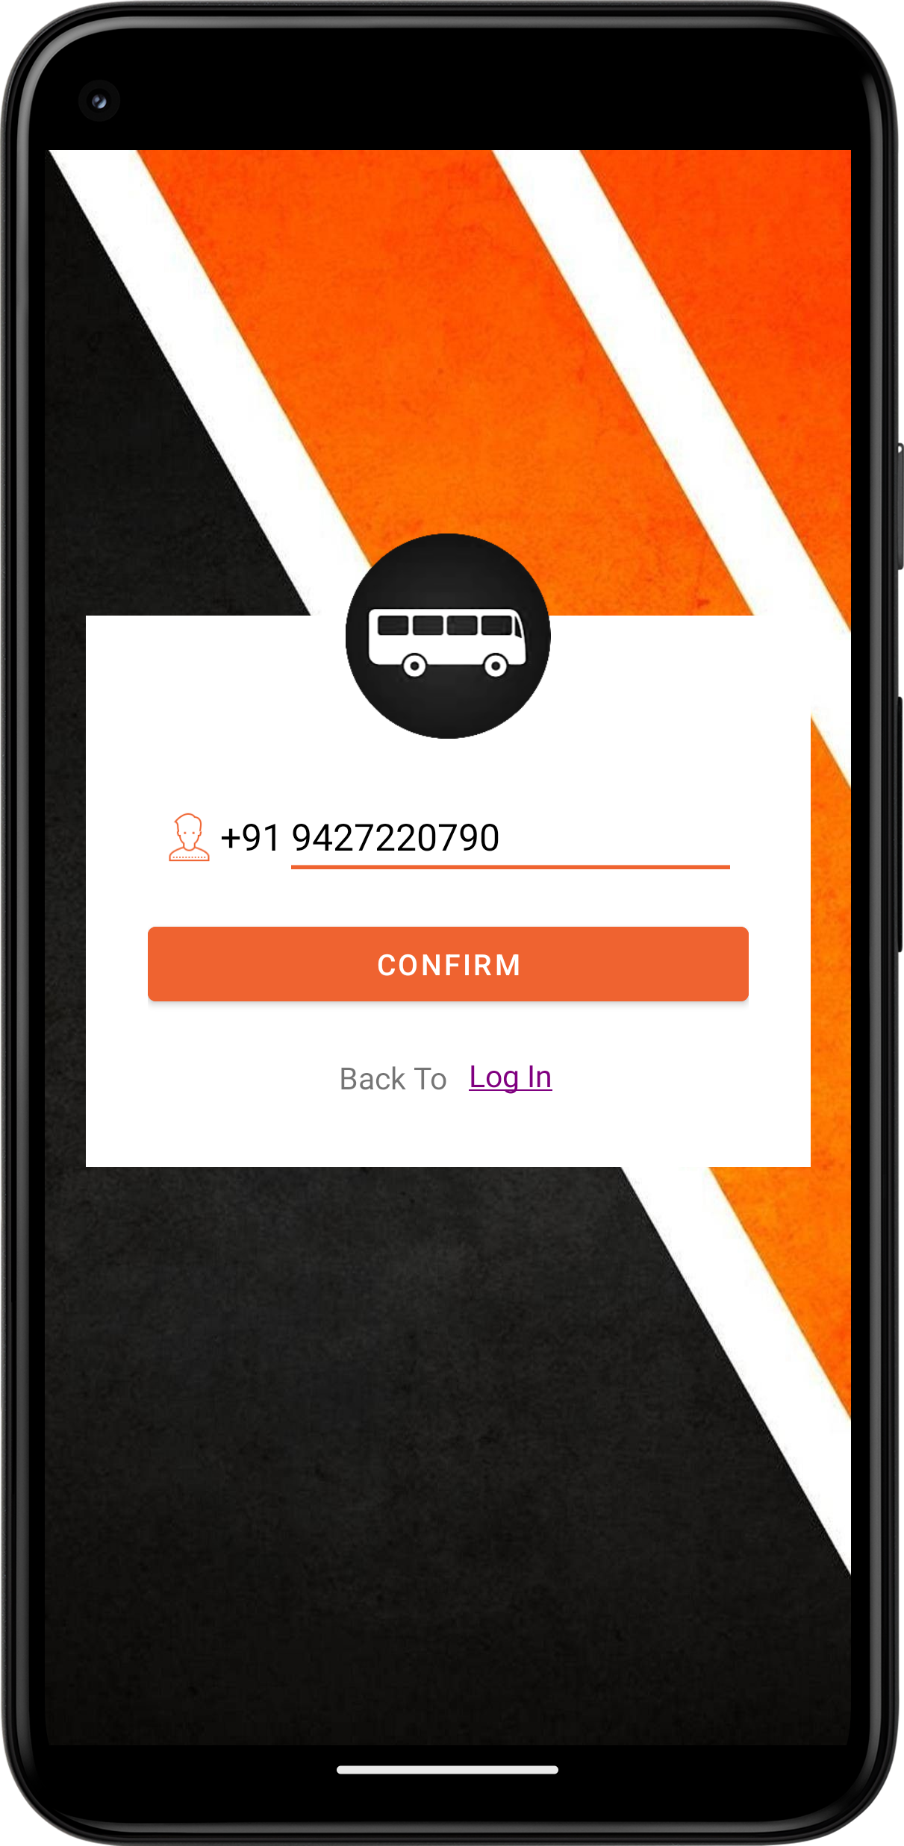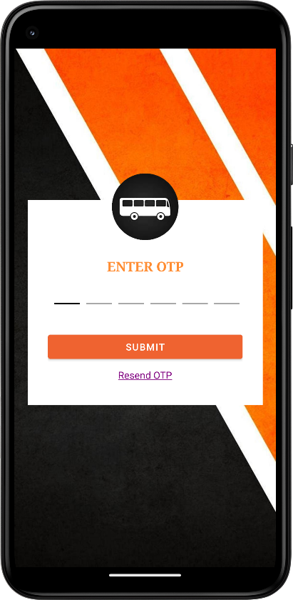 Forget Password Enter OTP

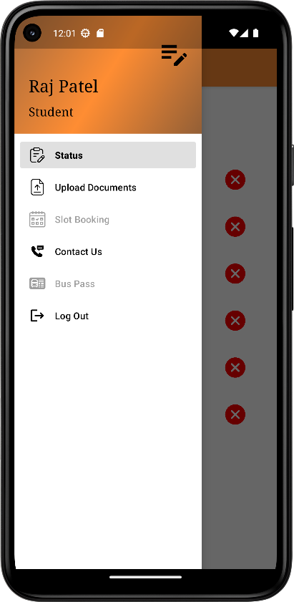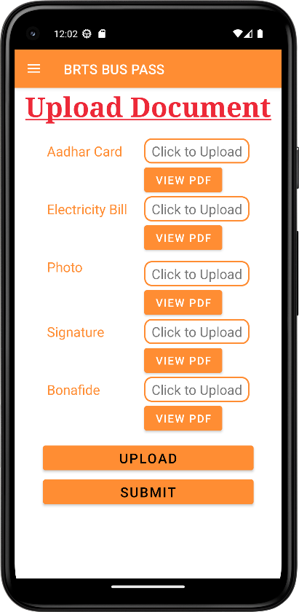 **Status Screen Nav Drawer Upload Document**

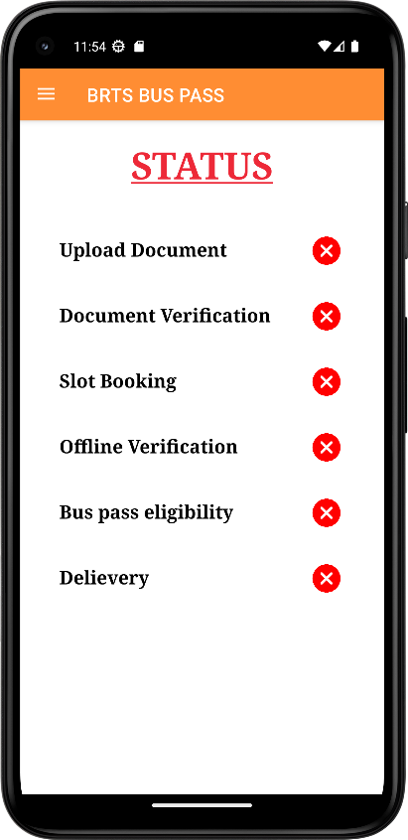

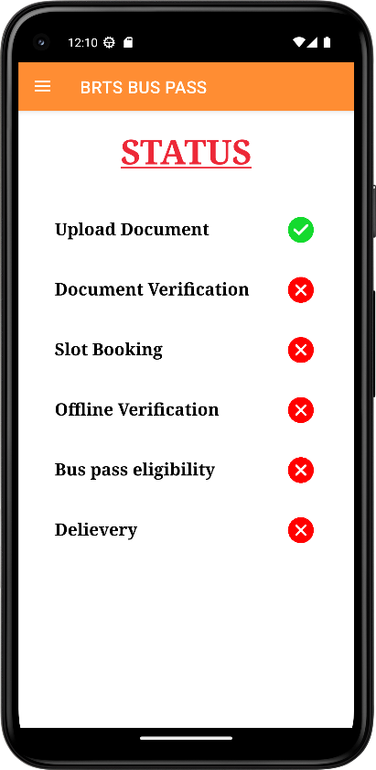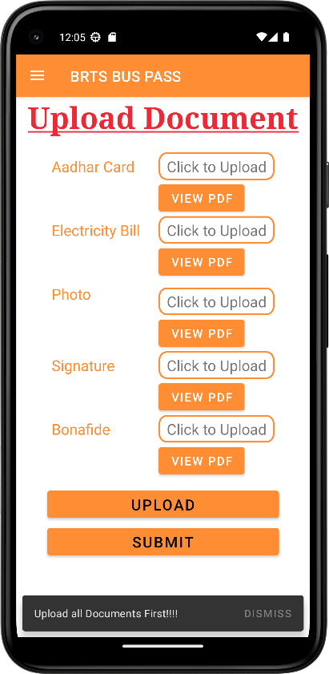**Upload Document(Validation) Upload Document Back to Status**

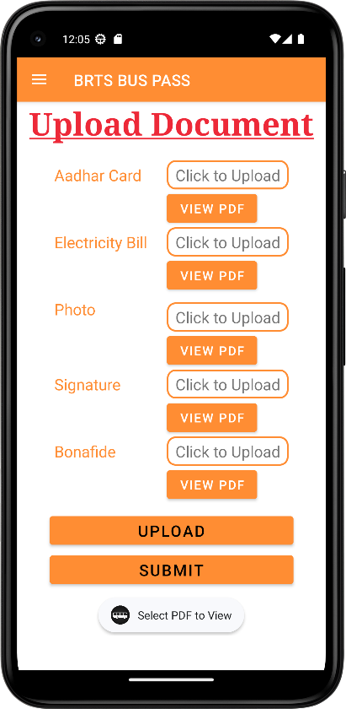

**Slot Booking Slot Booking Date Picker**

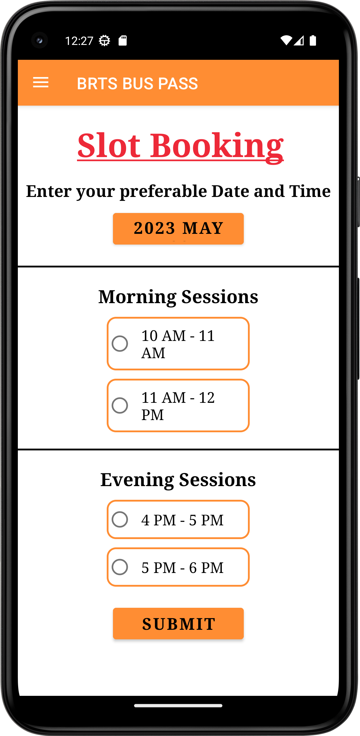 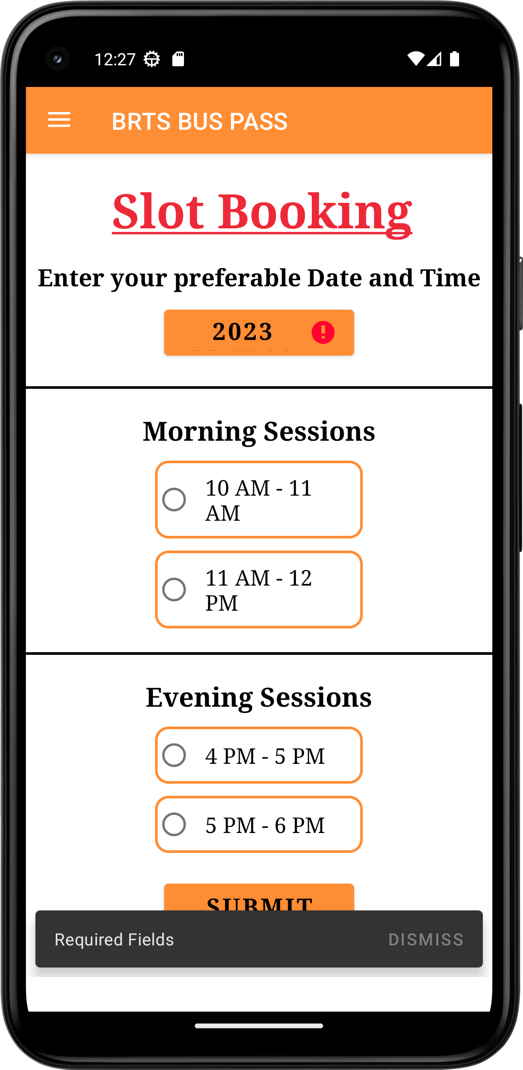 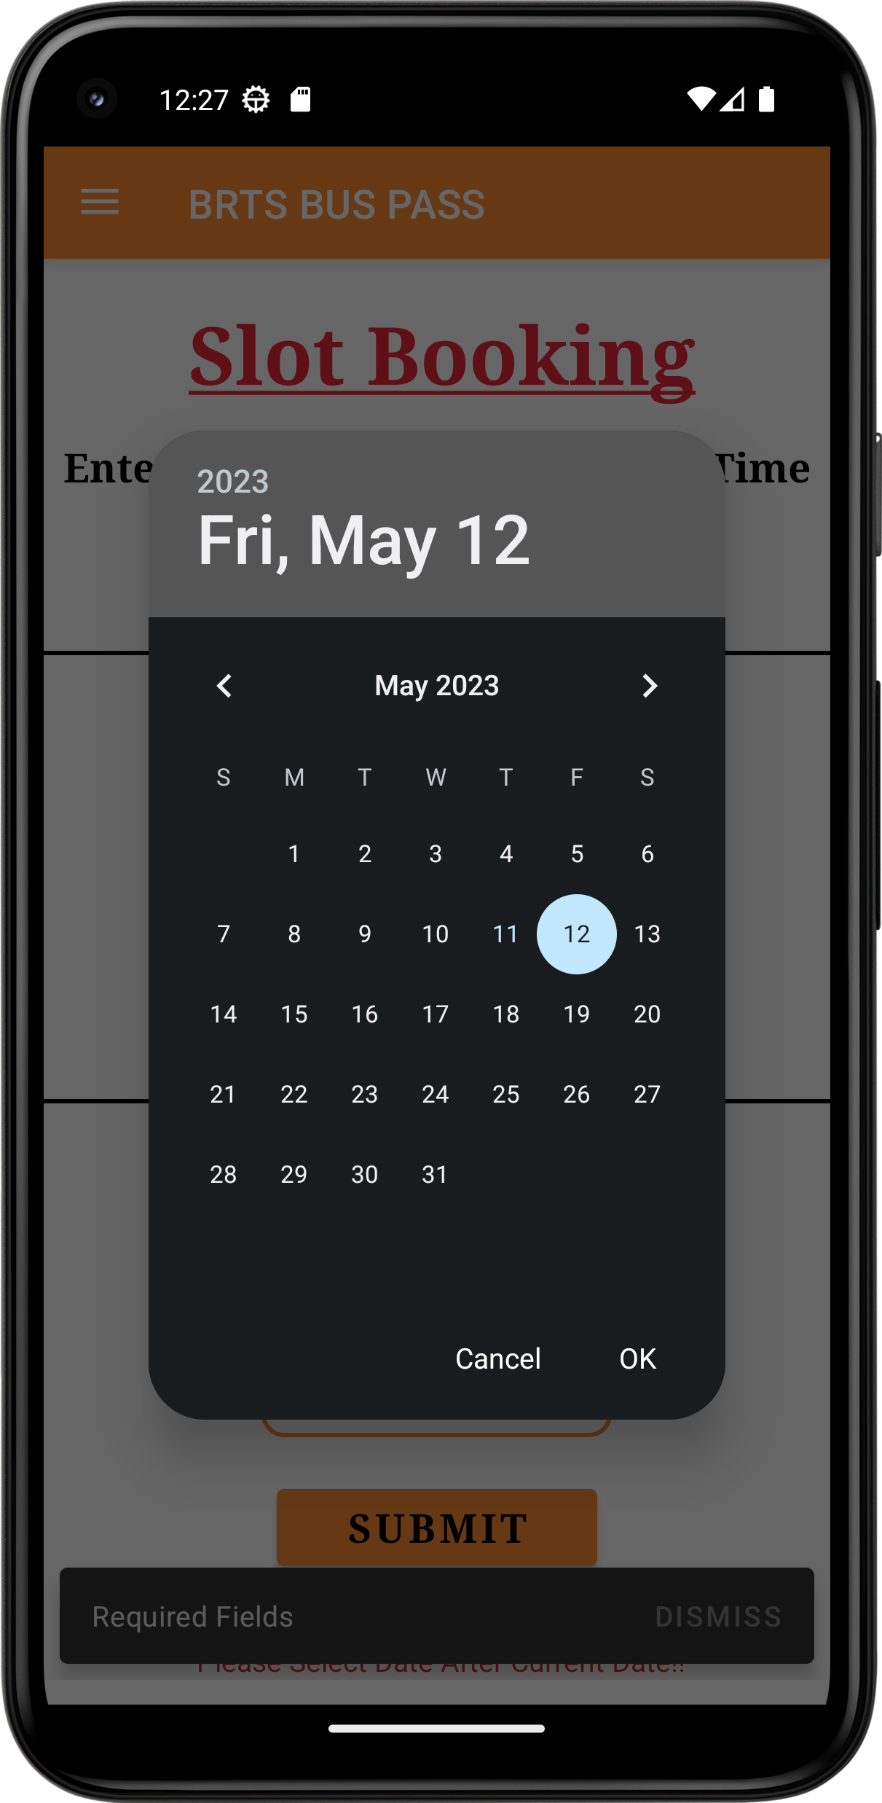

**Slot Selection Back to Status Slot Booked**

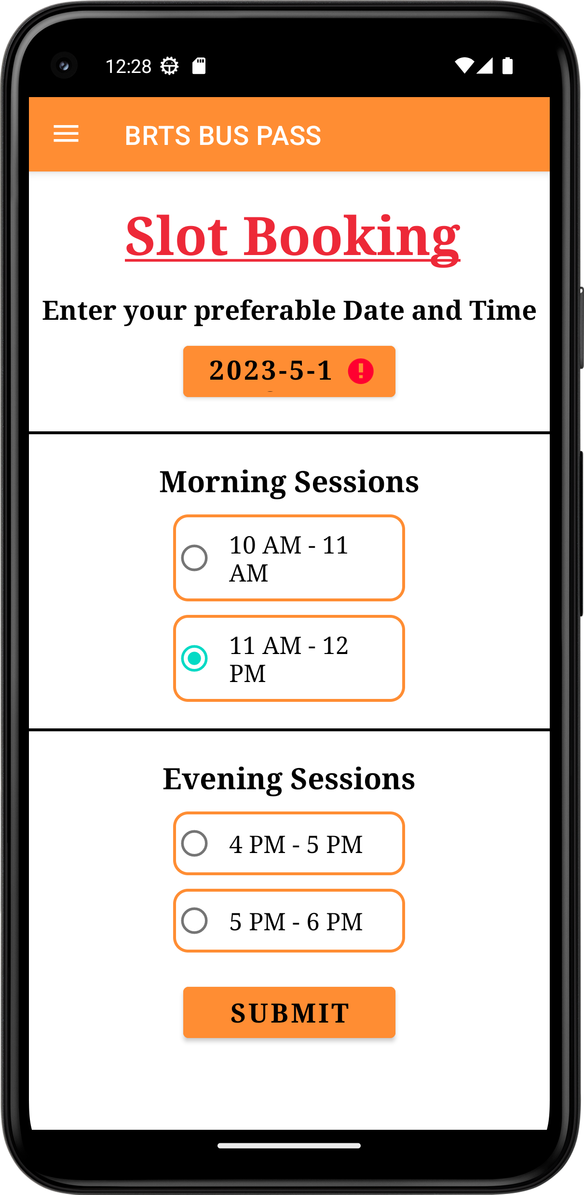 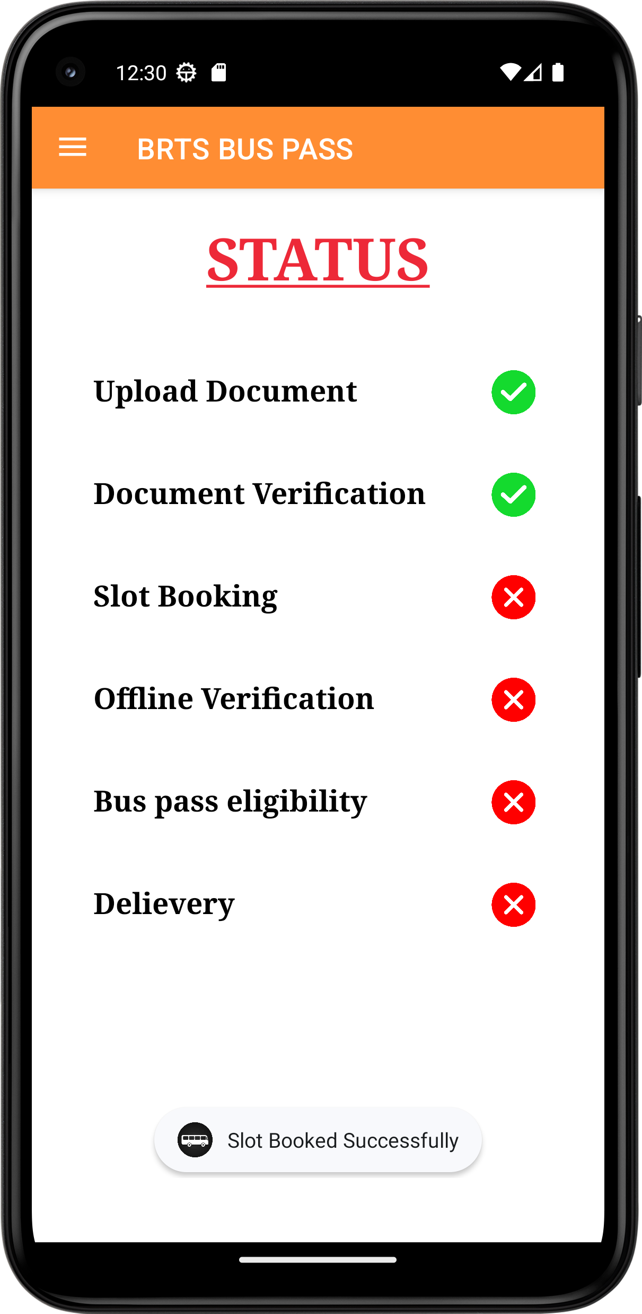 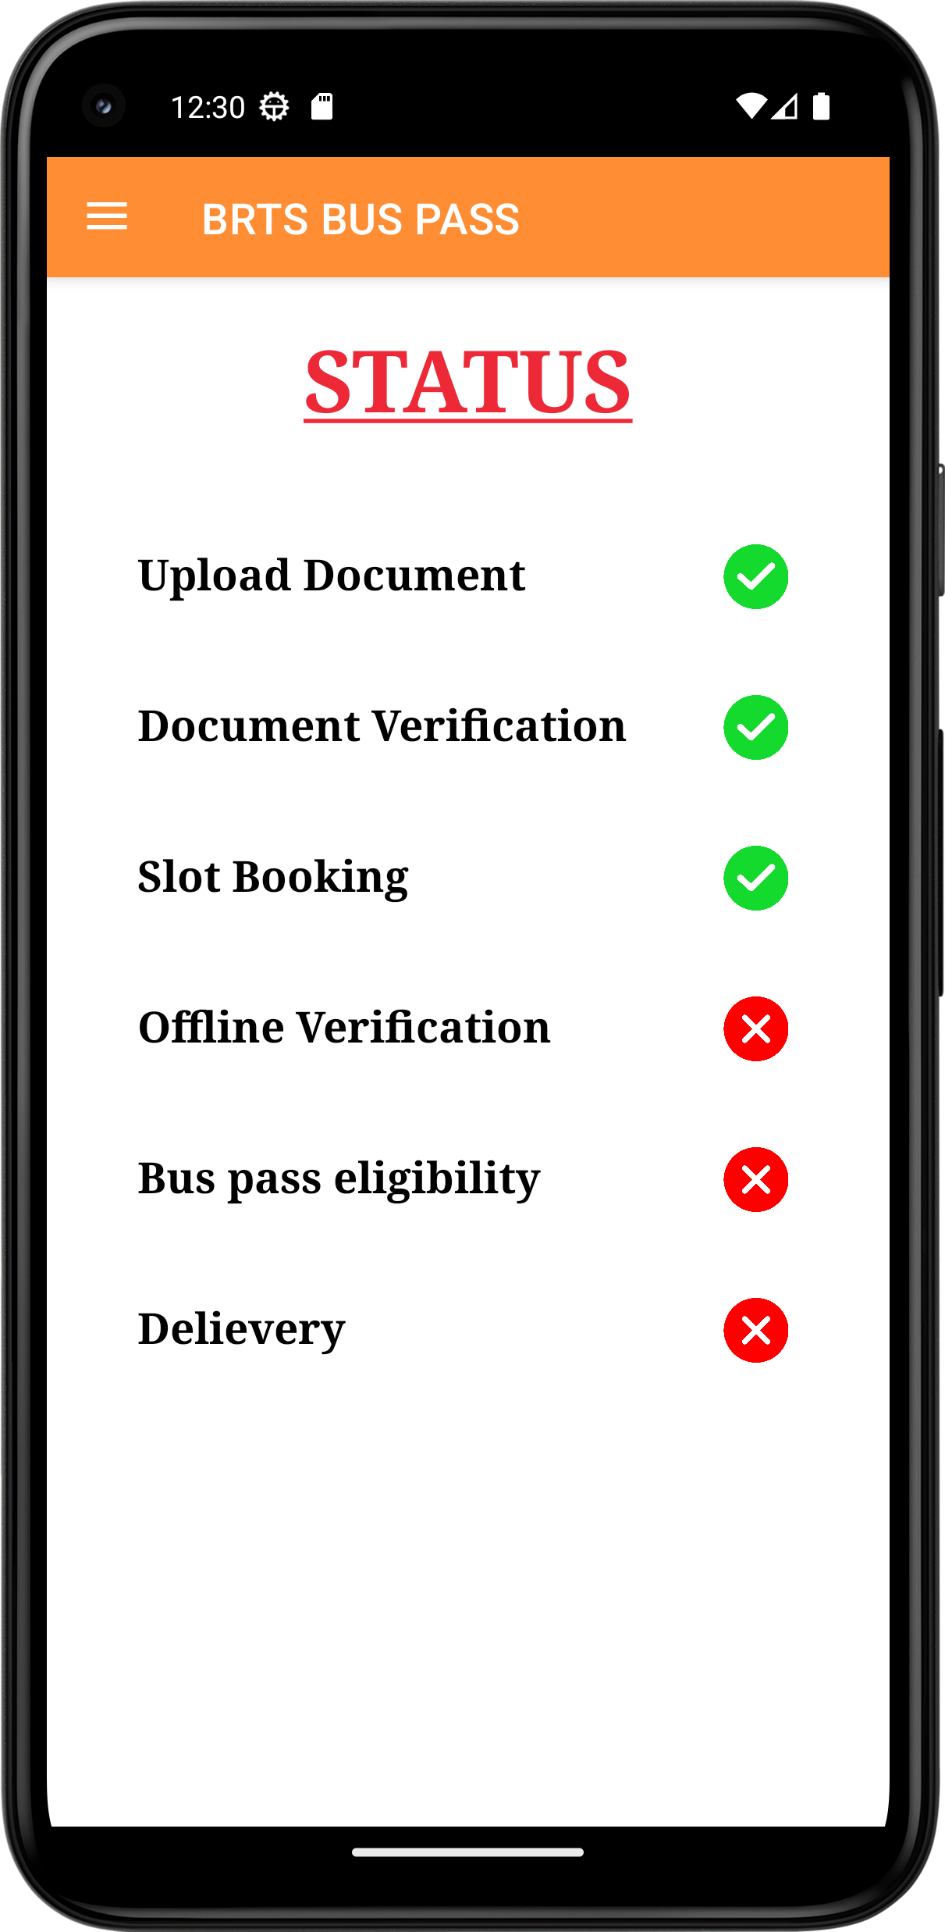

**Final Status UI Nav Drawer Click on buss Pass**

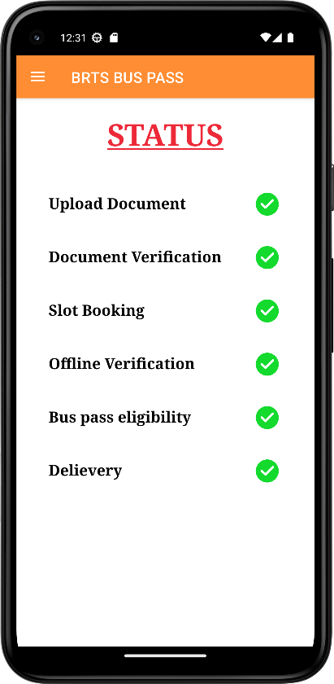 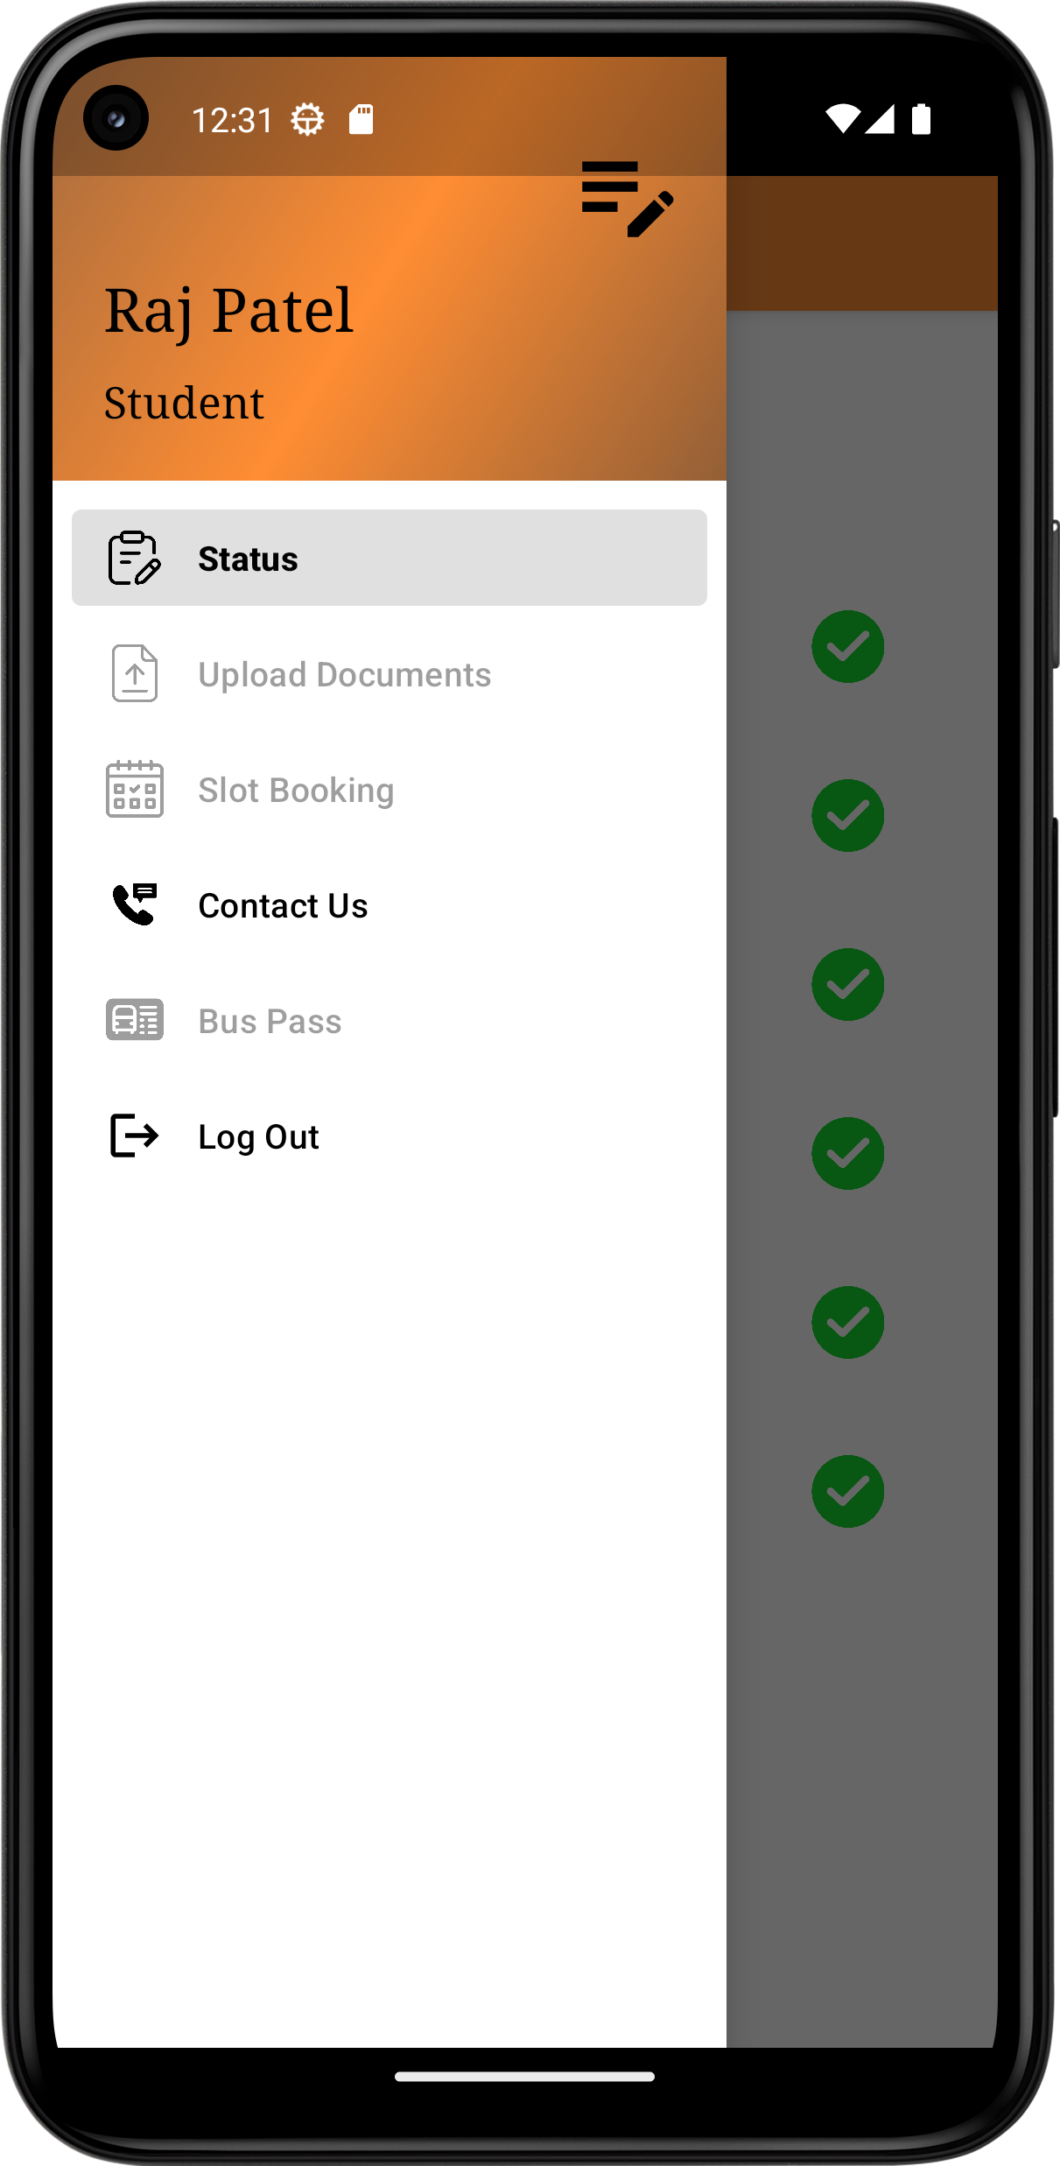 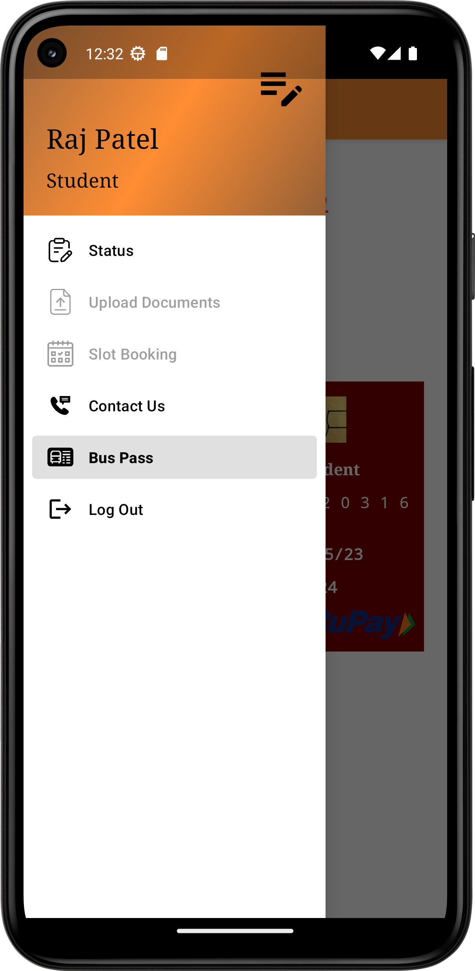

**Generated Bus Pass Contact us page Connect to our Email**

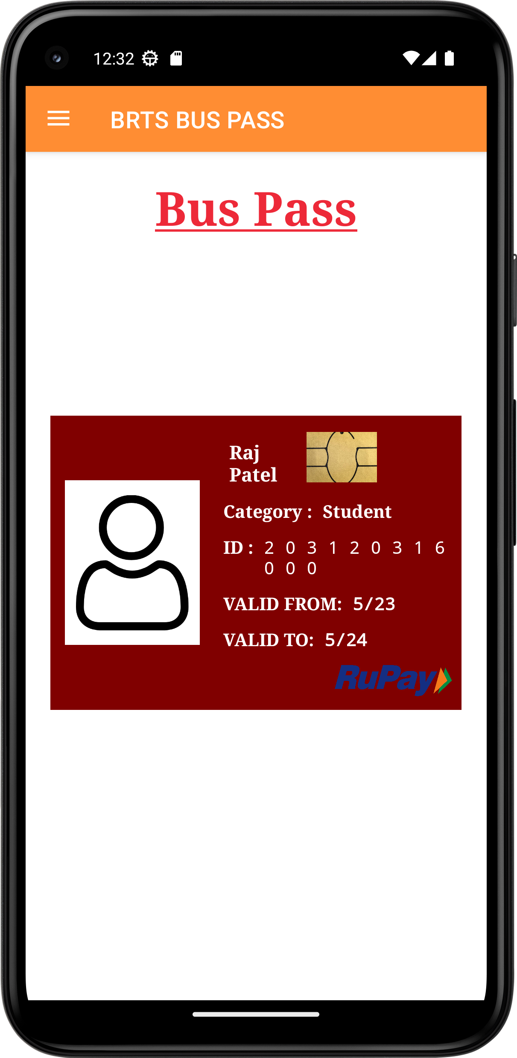 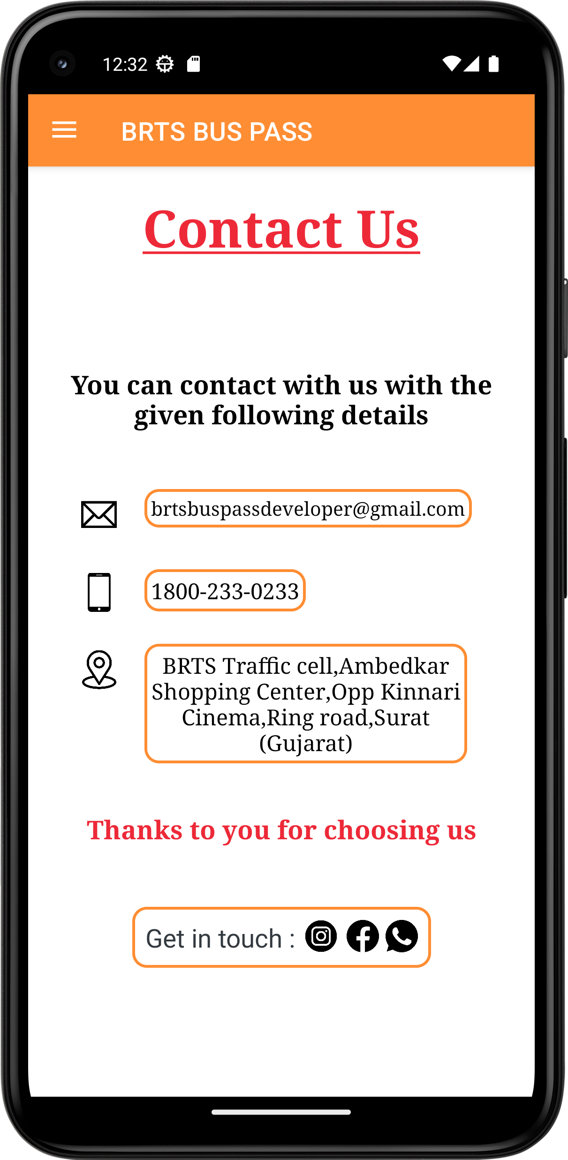 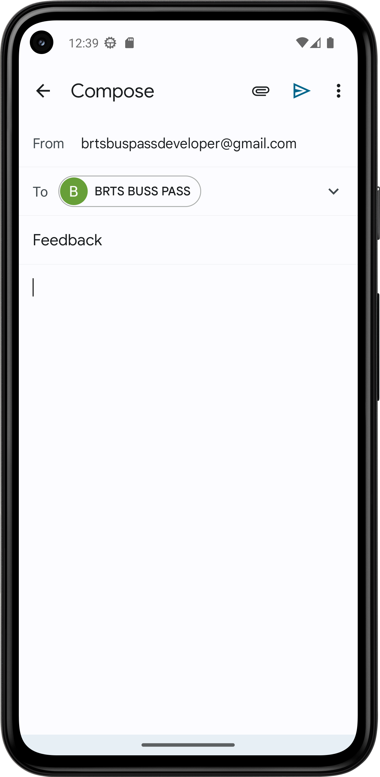

**Call To BRTS Office Click on location Location in Maps**

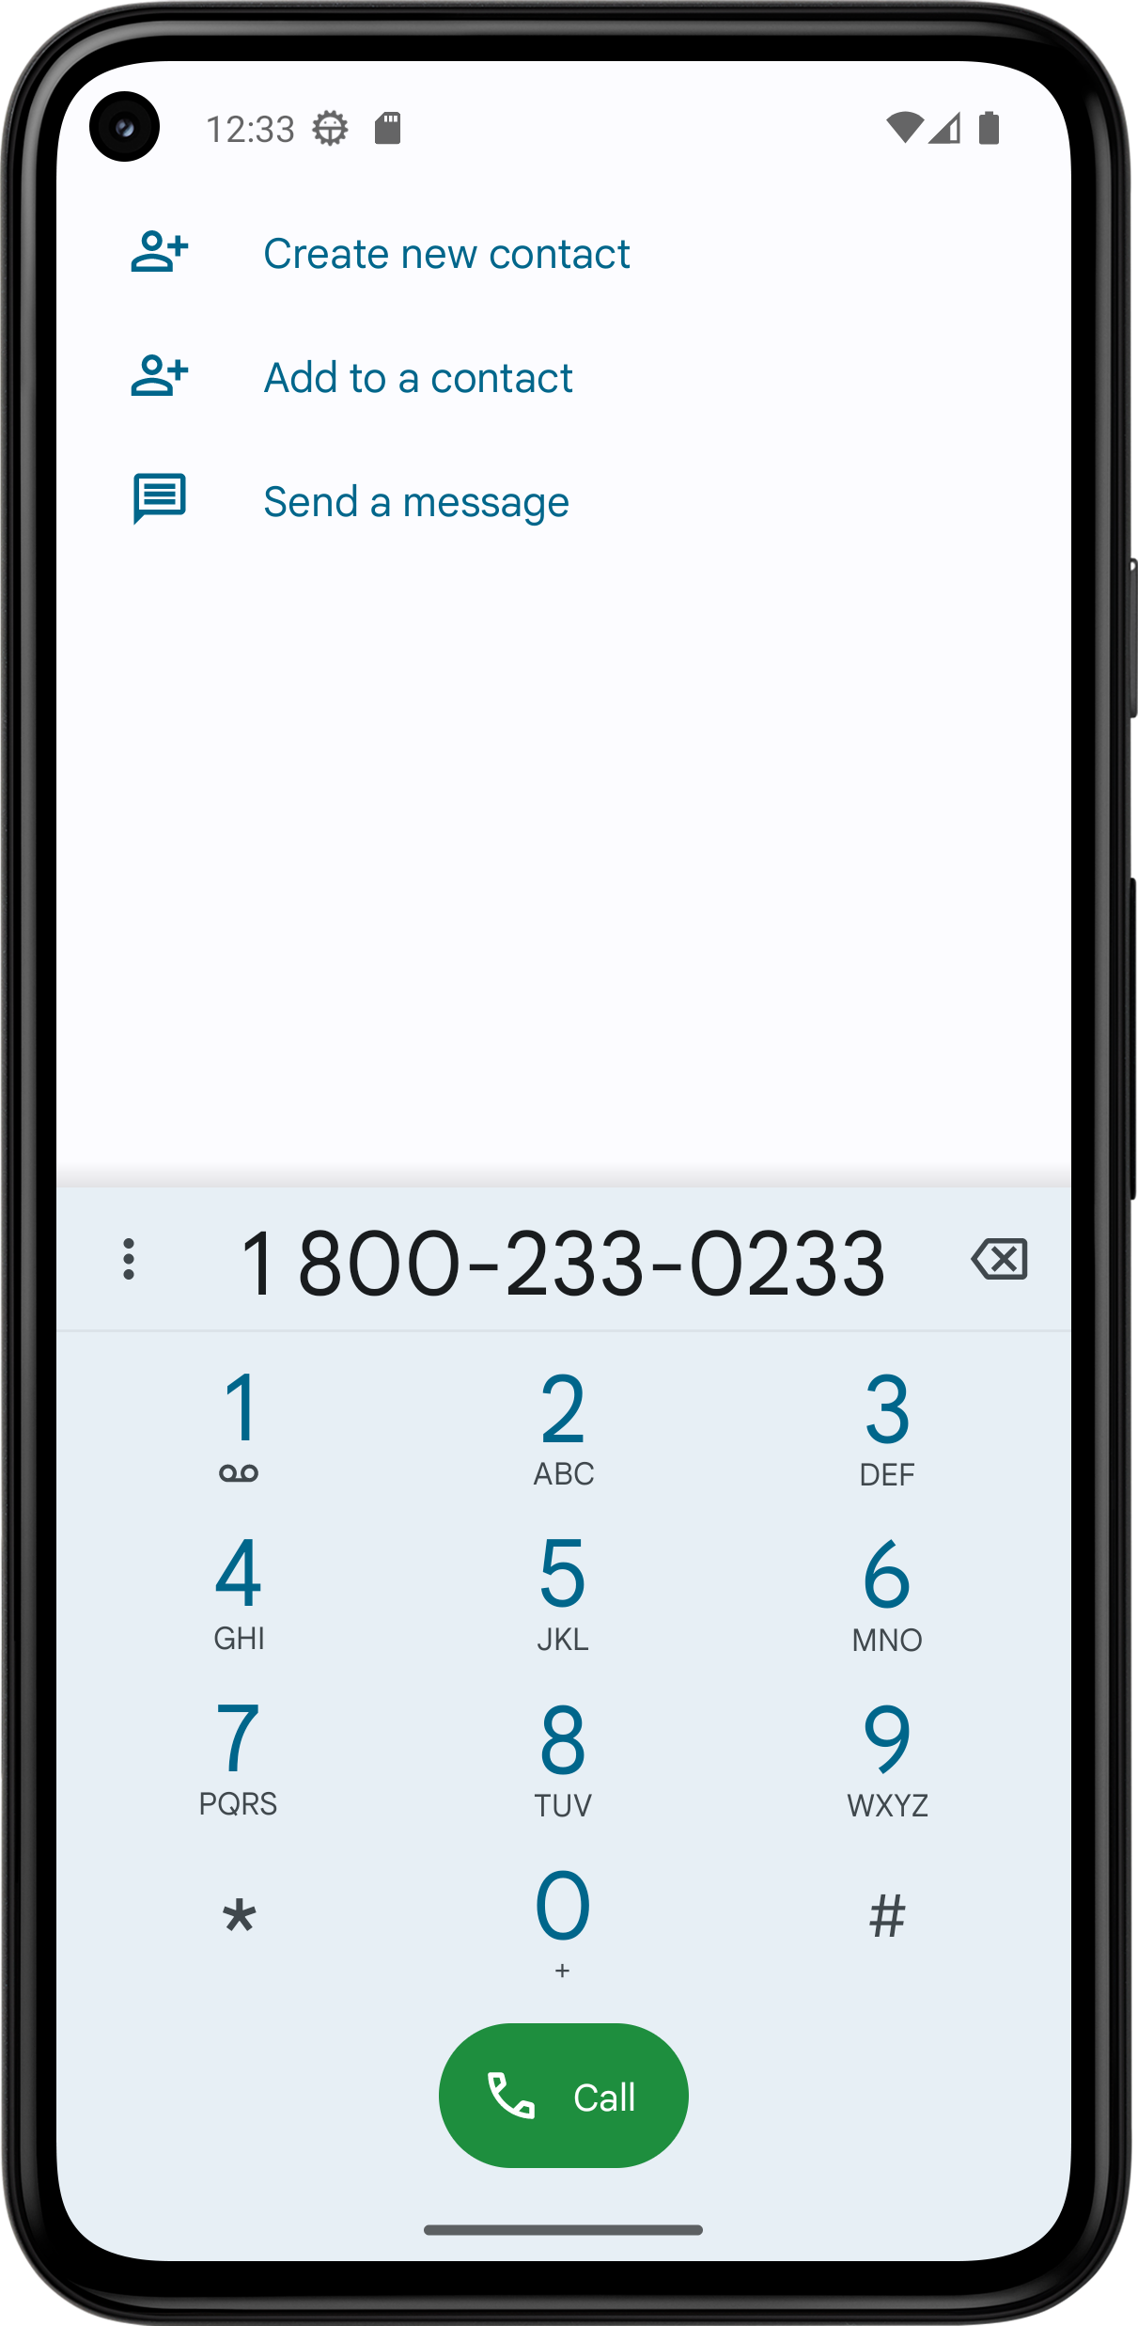 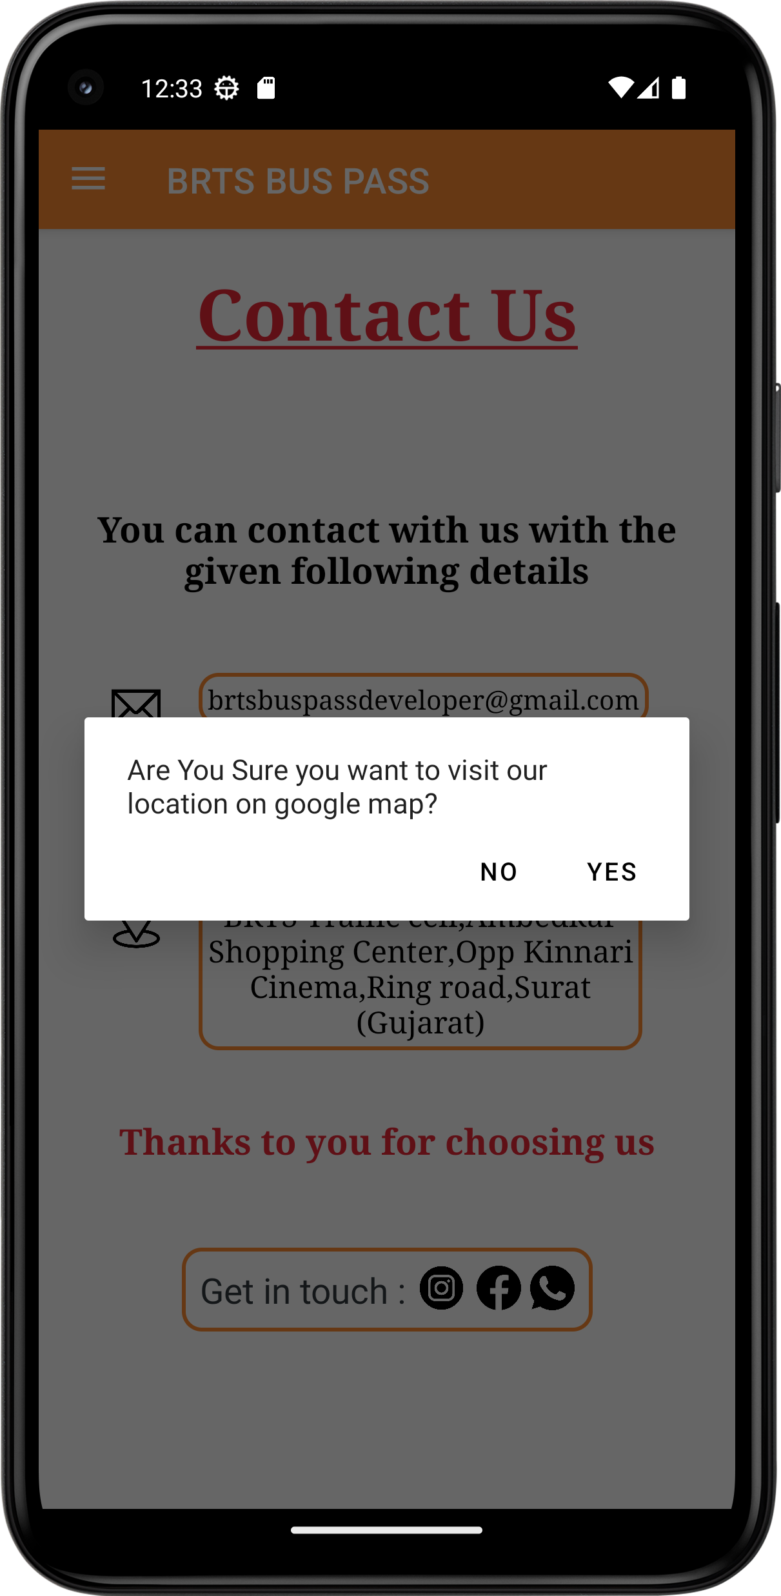 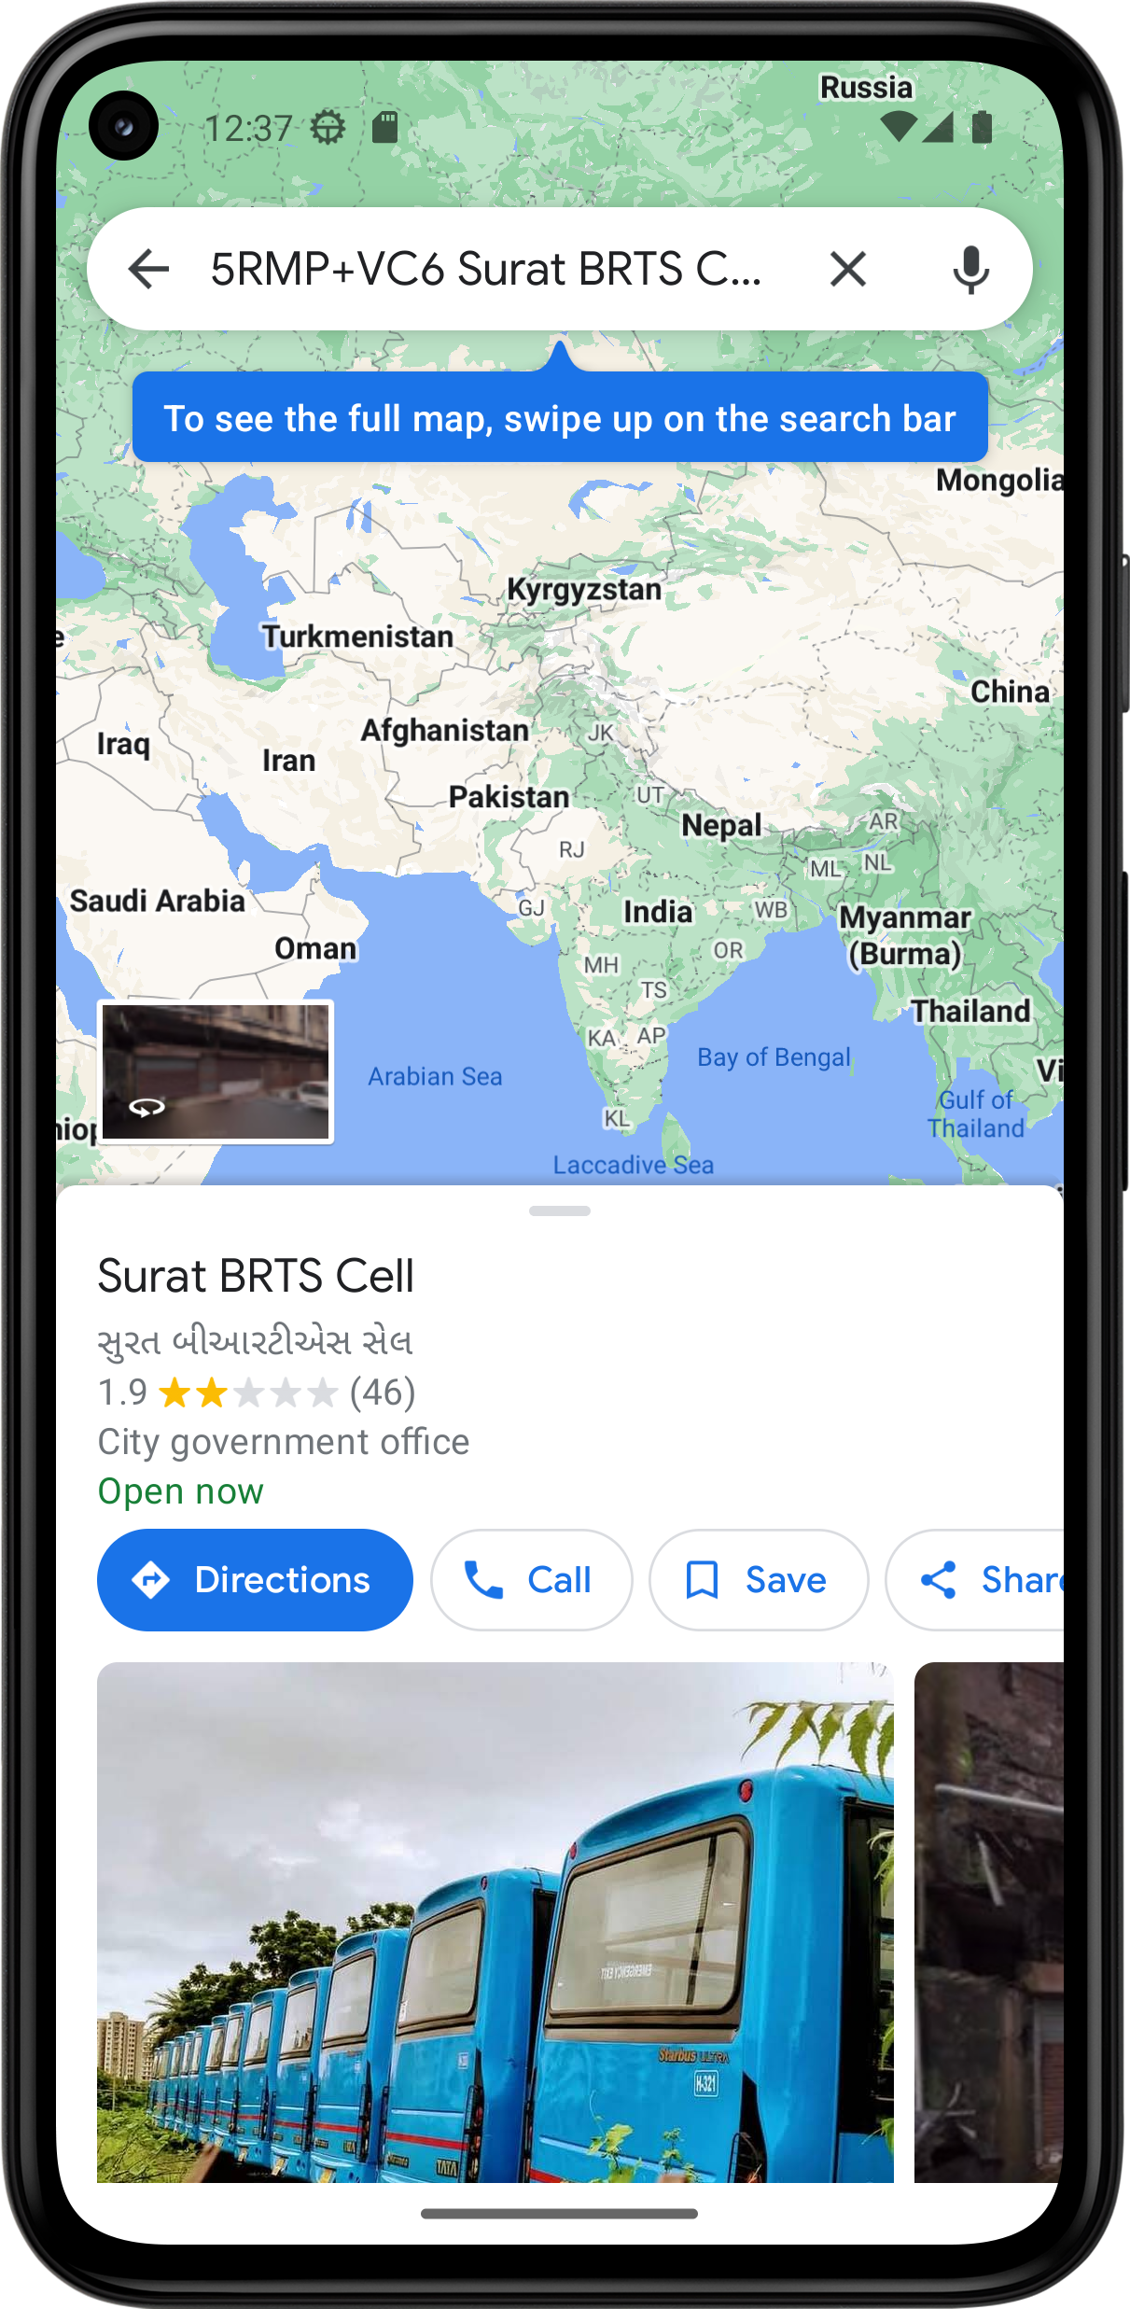

**Click on Facebook BRTS Facebook account User Profile**

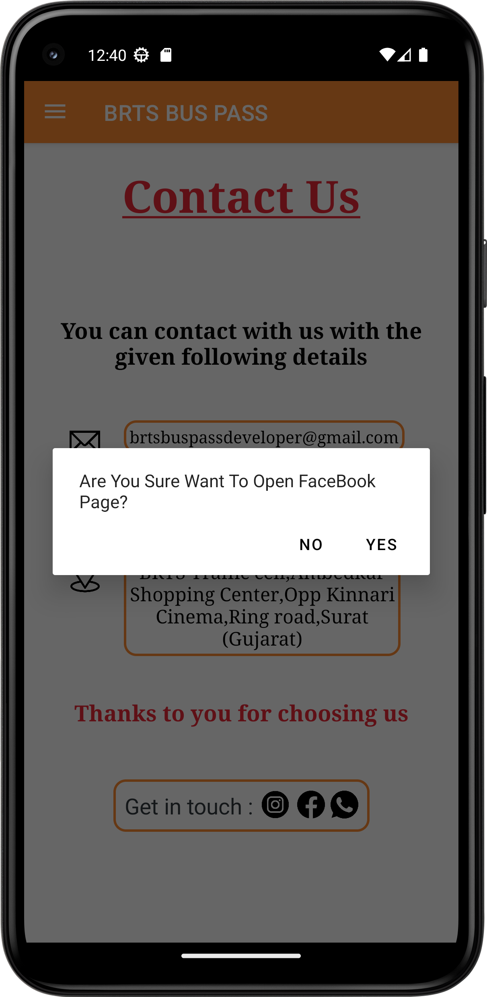 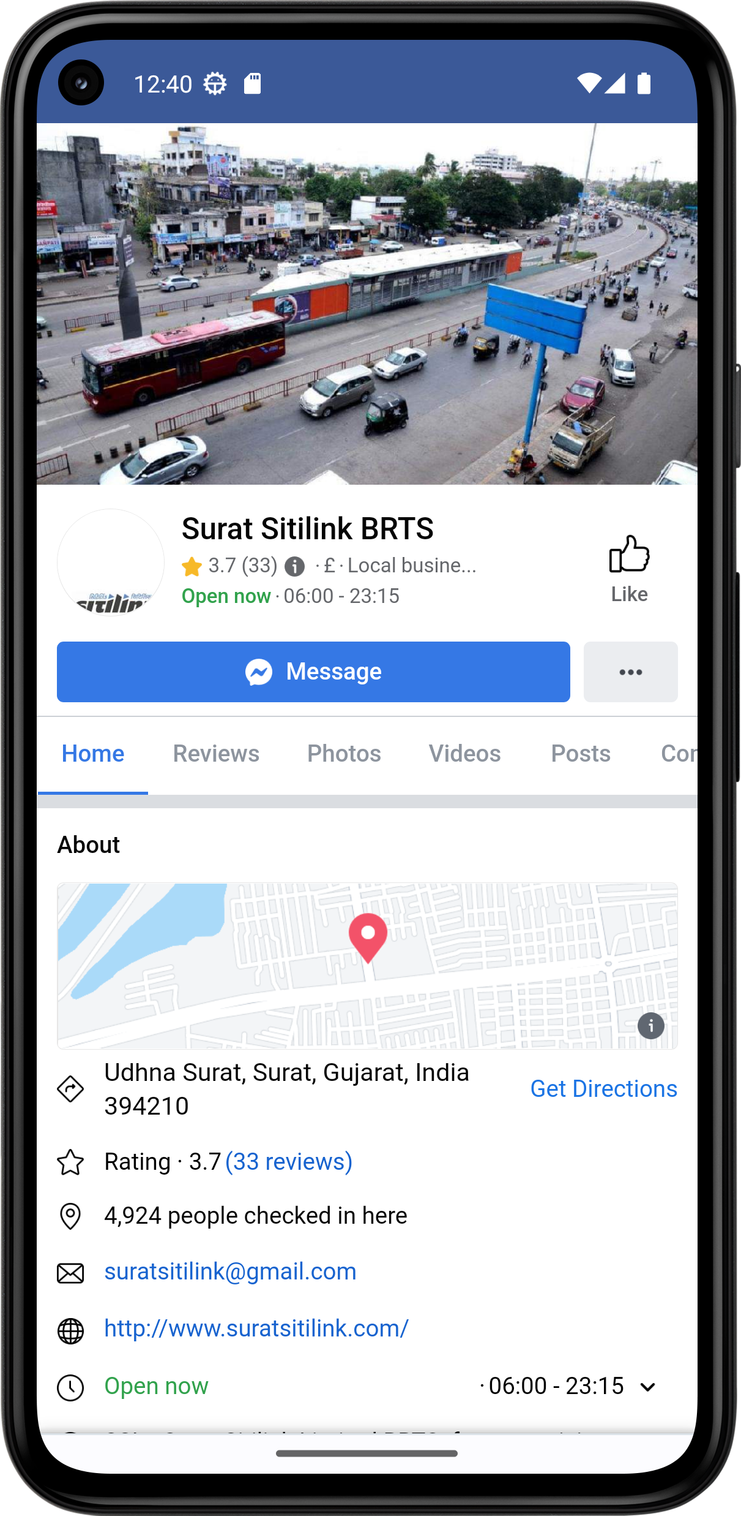 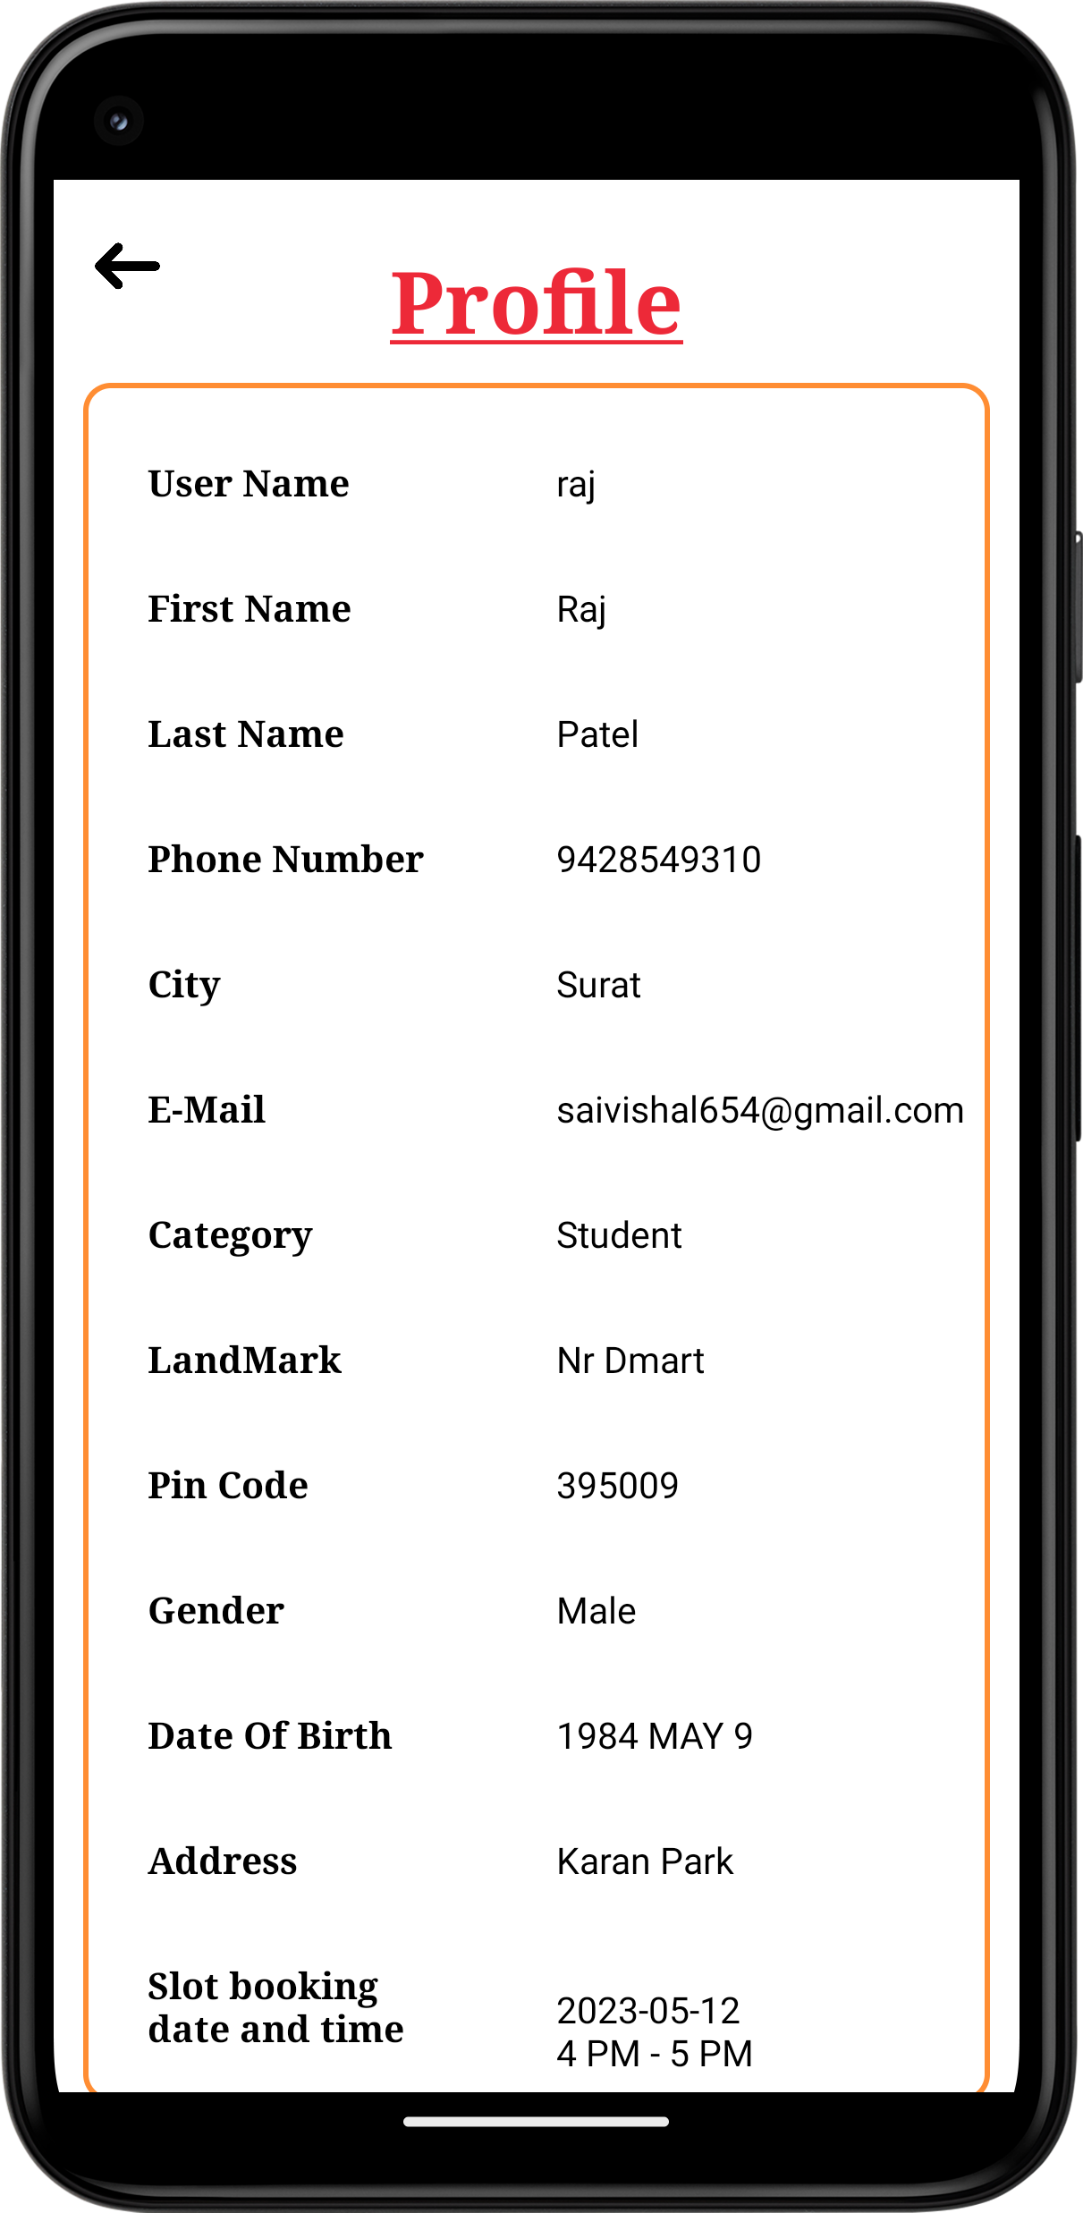

**Click on Log Out Back to log in page**

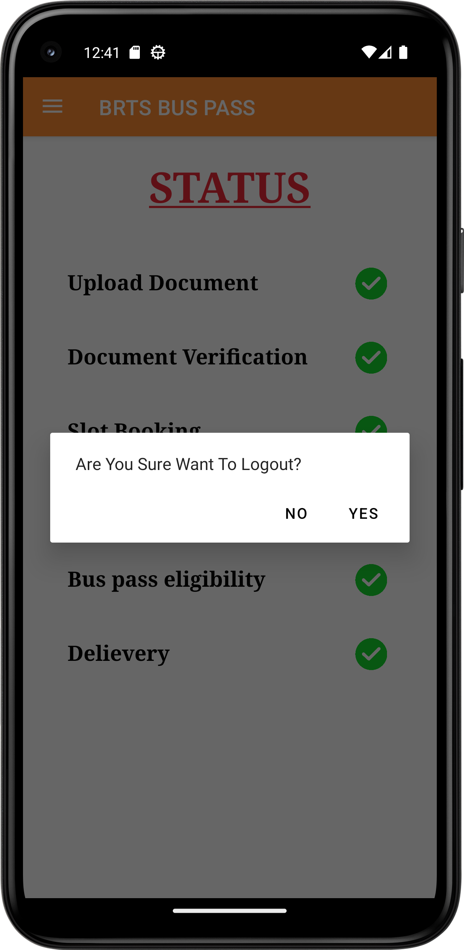 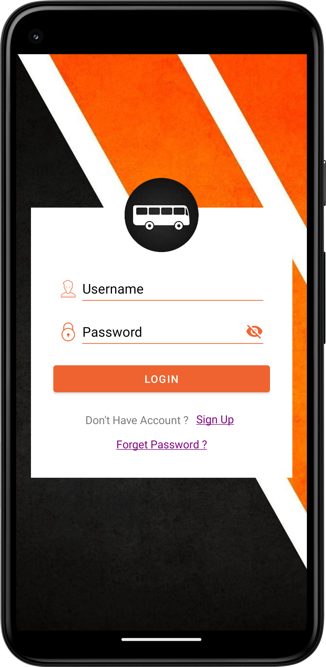

**5.2 UI FOR ADMIN Website**



**Sign in Page**

**Admin Panel After Log in**

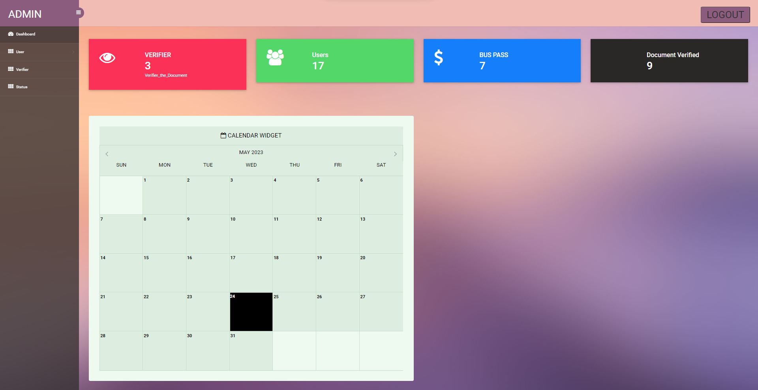

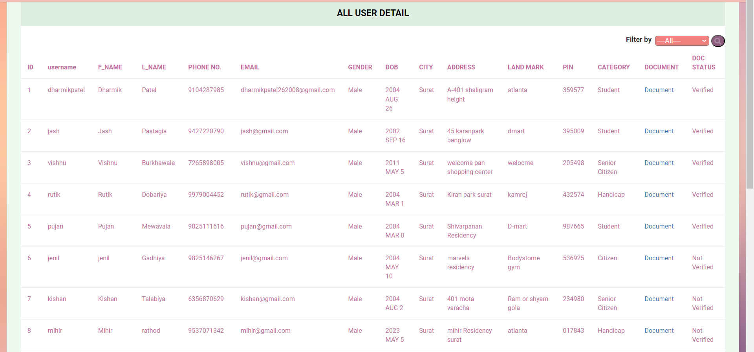**User Details Tables**

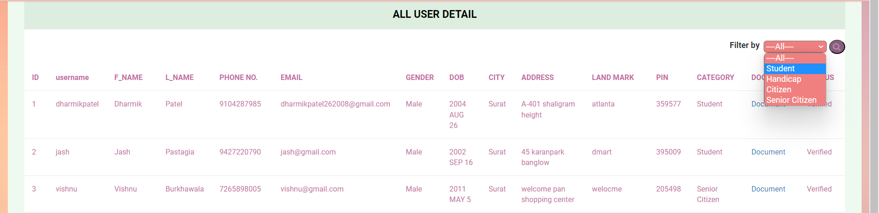**User Detail With Filter**

**Pending User Detail Table**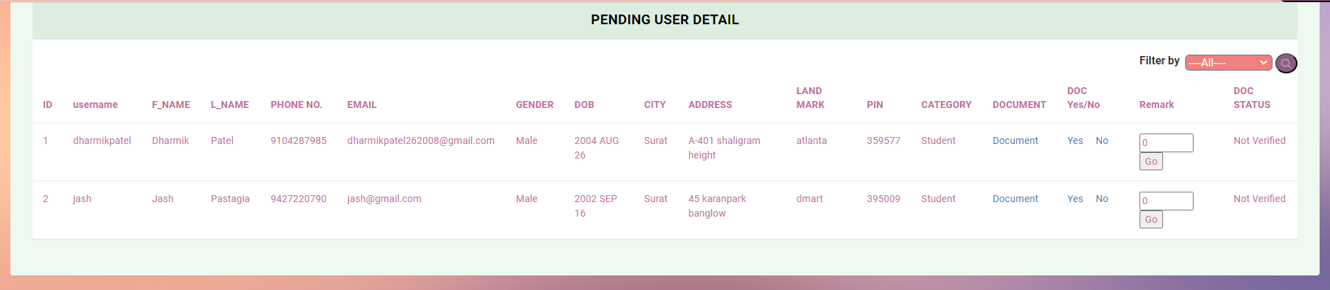

**Document Upload Panel of Users**

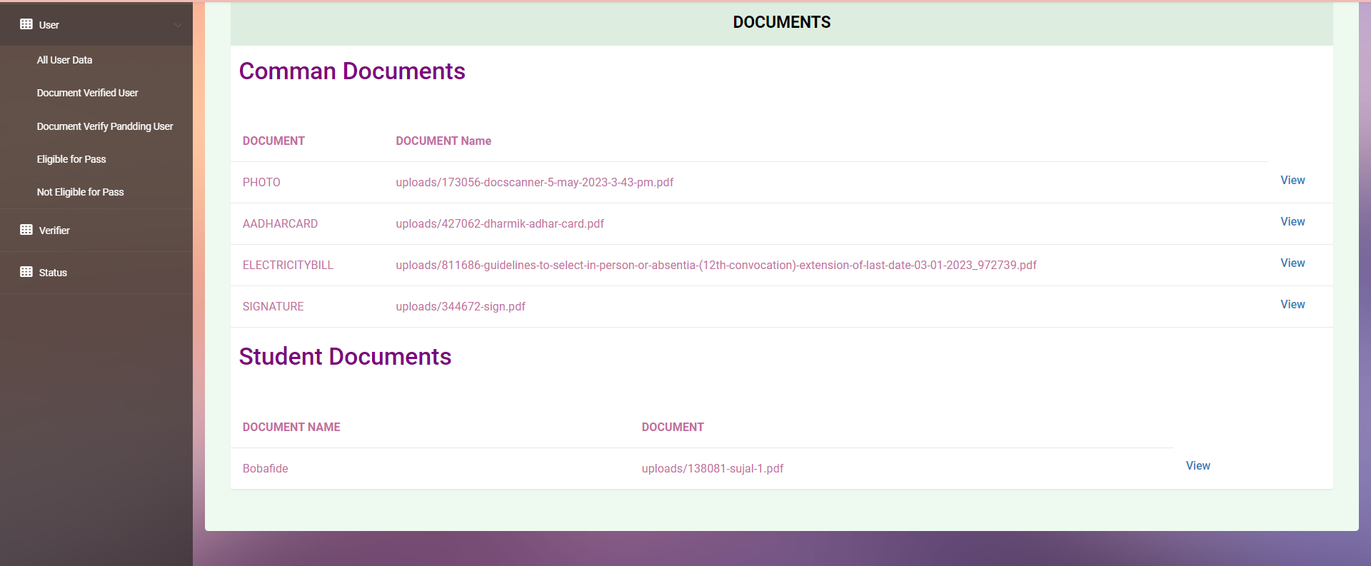

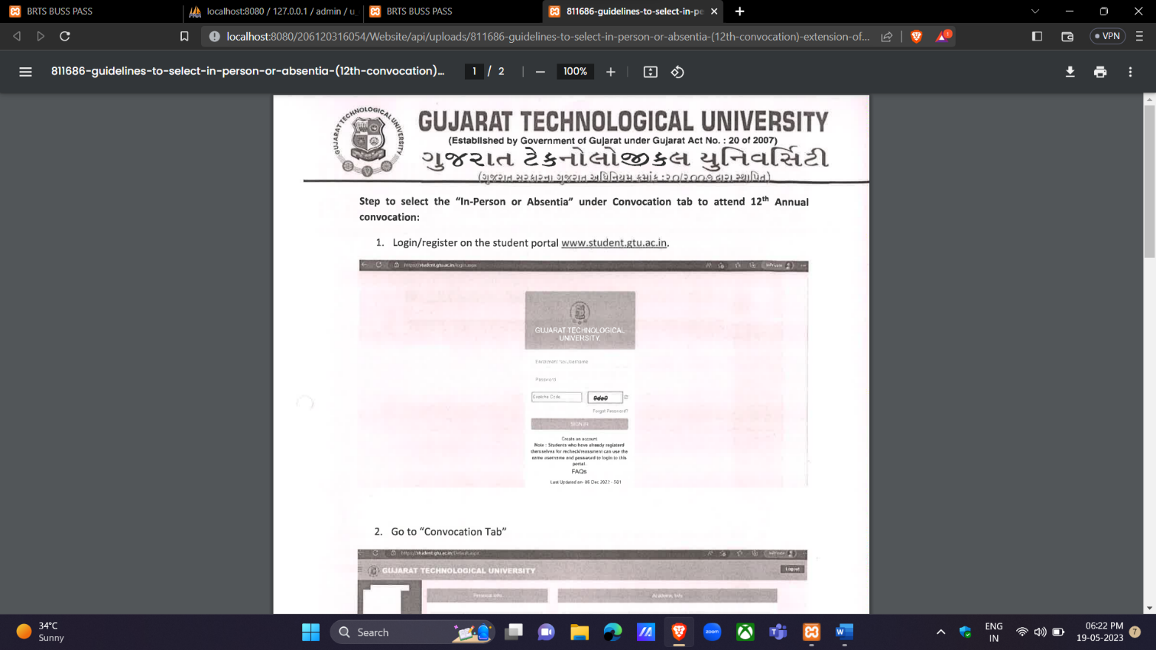**View PDF uploaded by user**

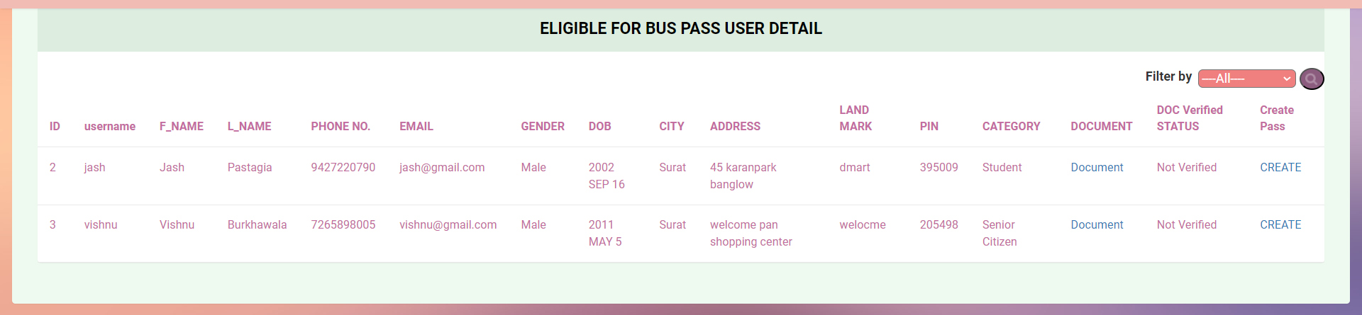**User Details which are eligible for BUSS PASS**

**Created Buss Pass Of a user**

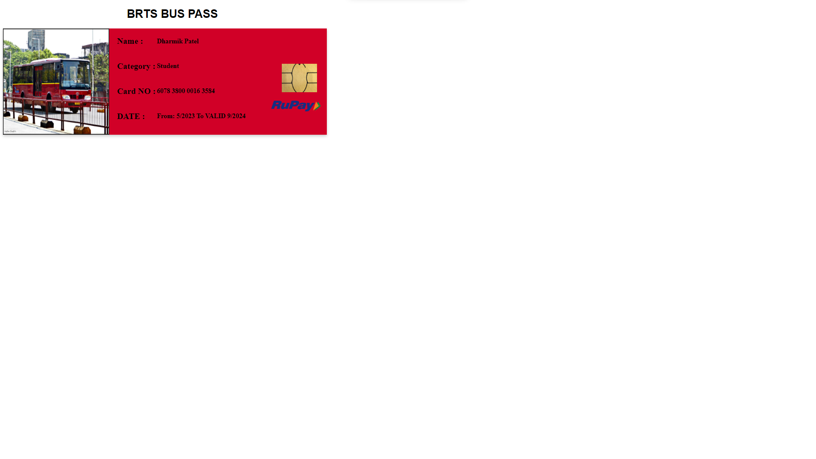

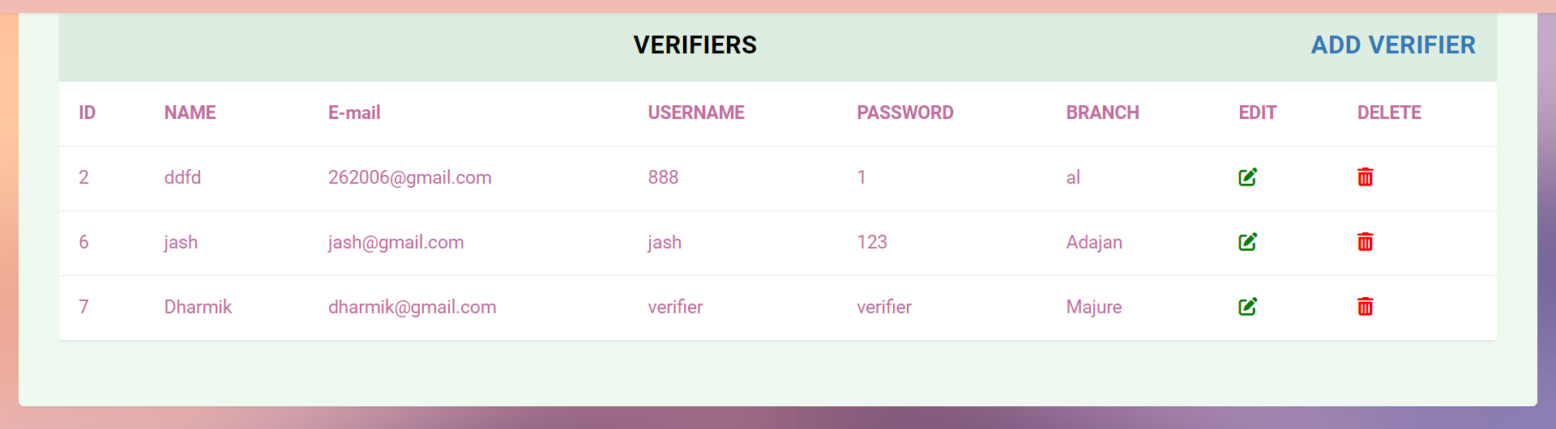**List of Verifiers**

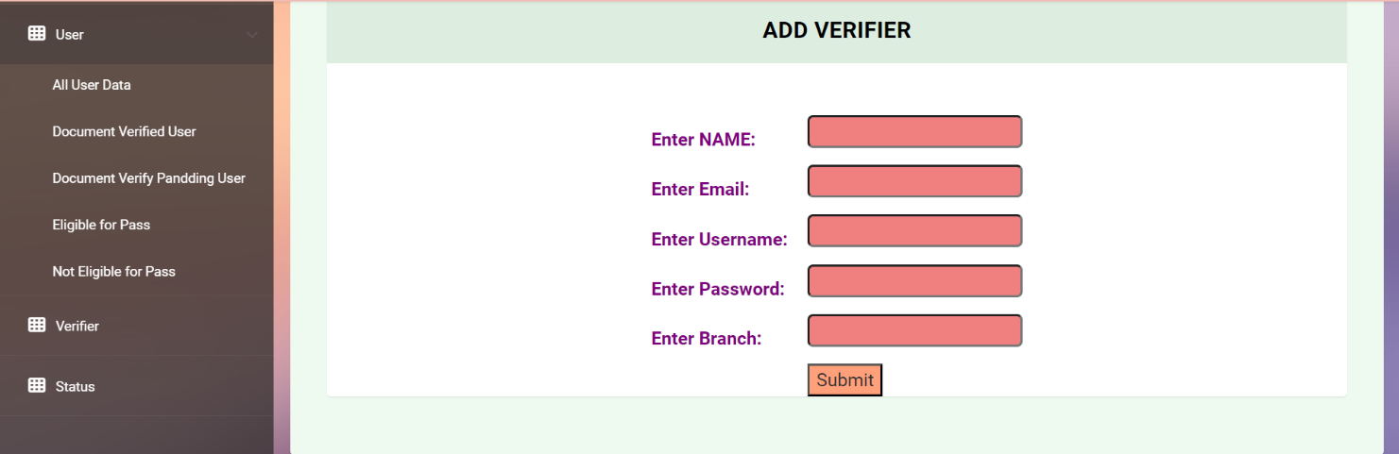**Verifier can be added by this page**

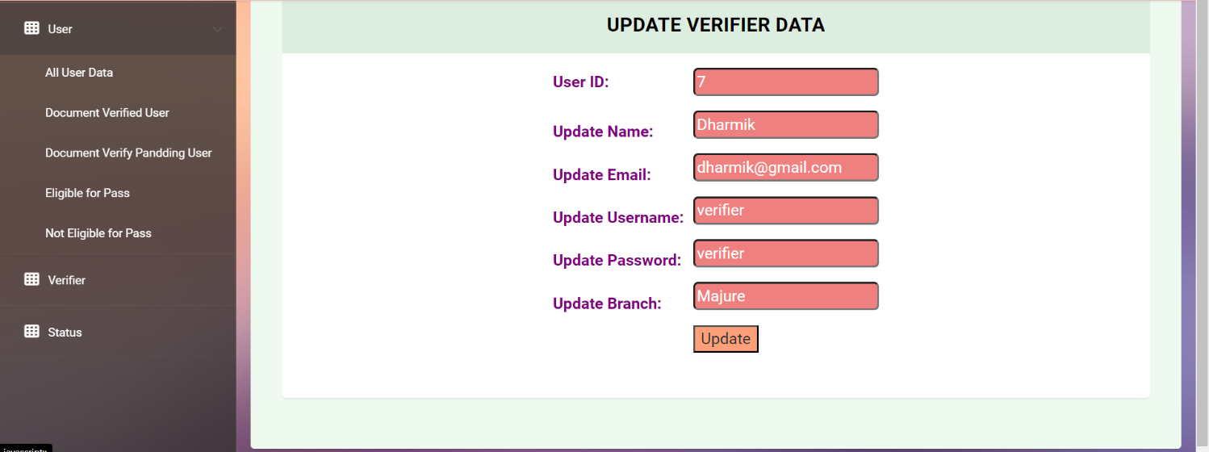**Update data of a Verifier**

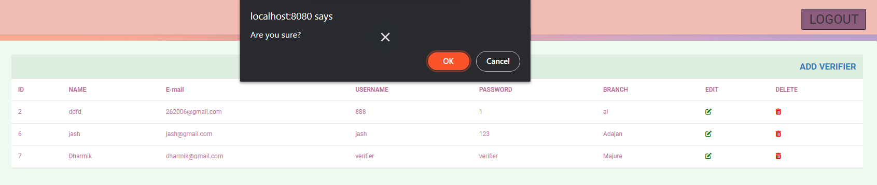**Can Delete Verifier**

**Admin can get more information by status page**

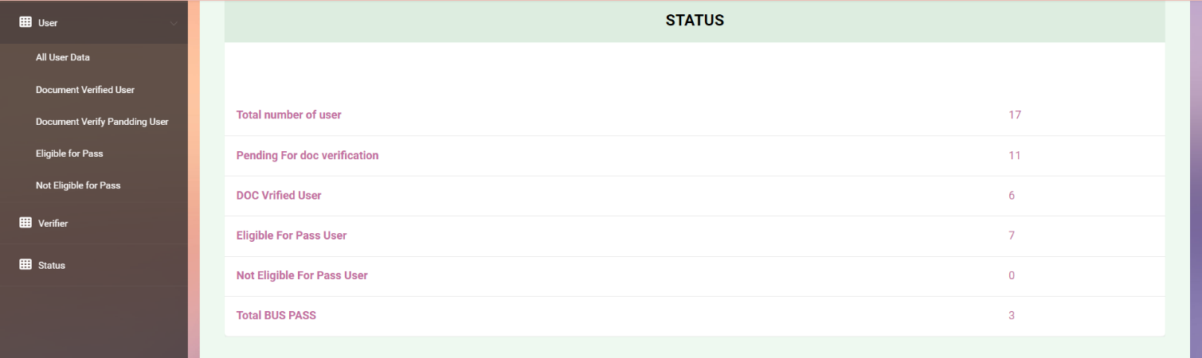

**5.3 UI FOR VERIFIER Website**

**Dashboard For Verifier**

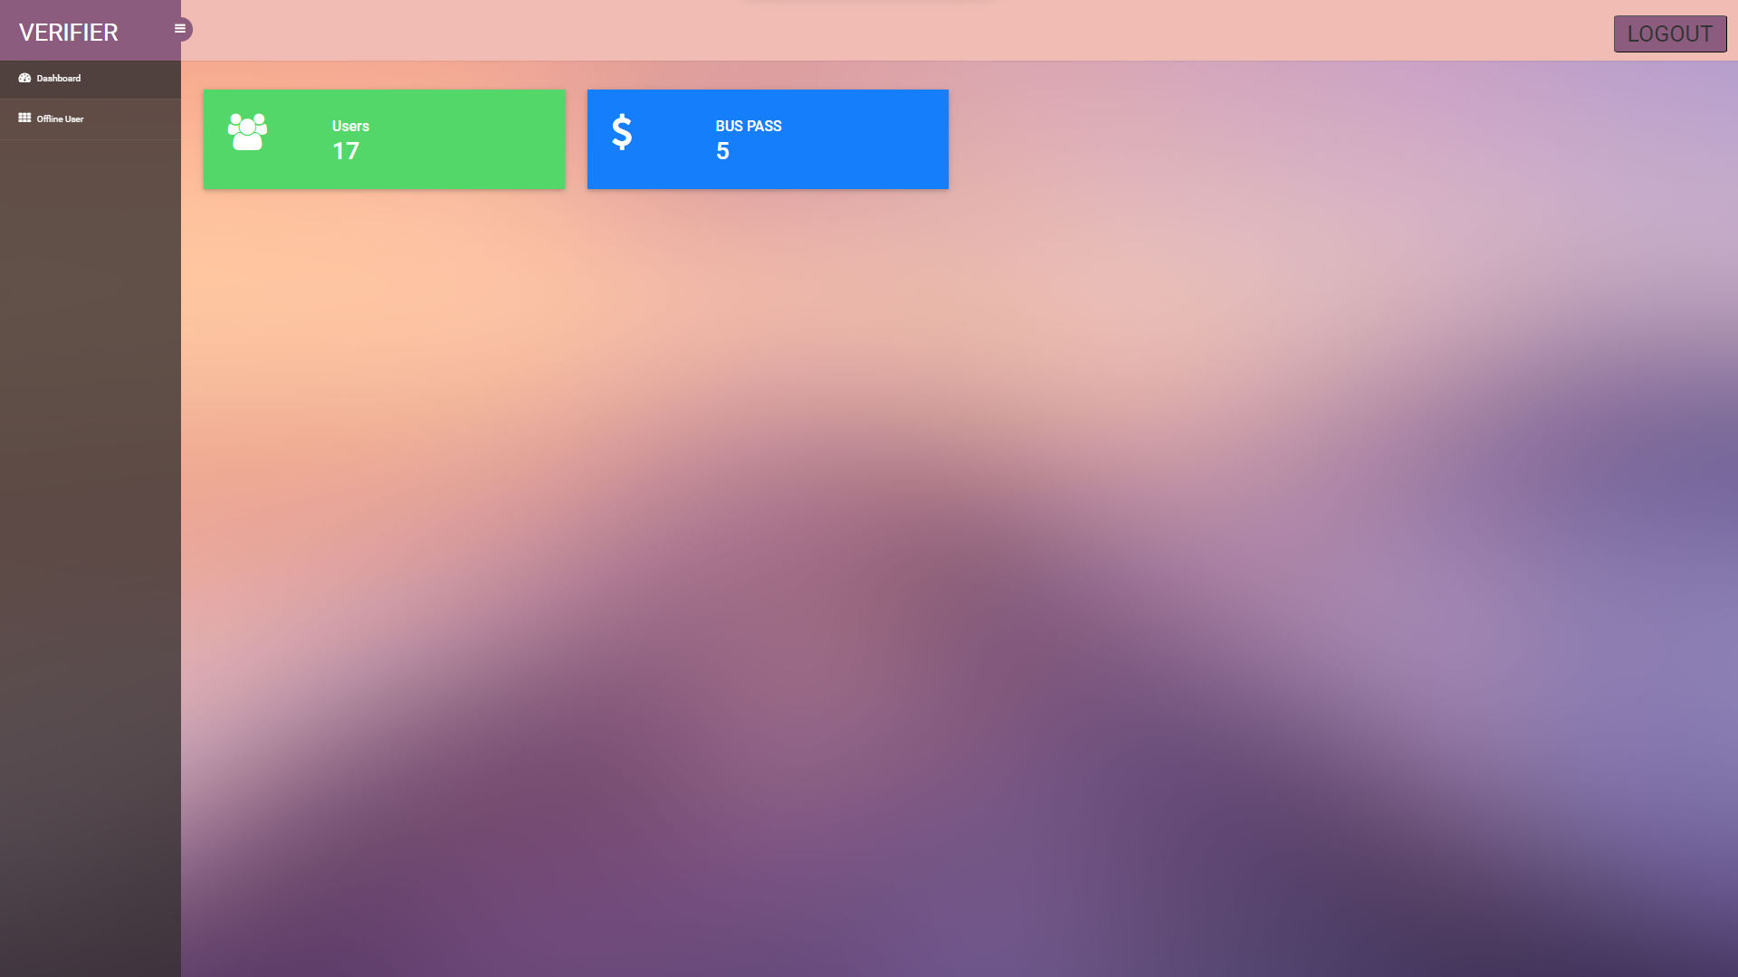

**User detail for verifier(With filtering Date feature)**

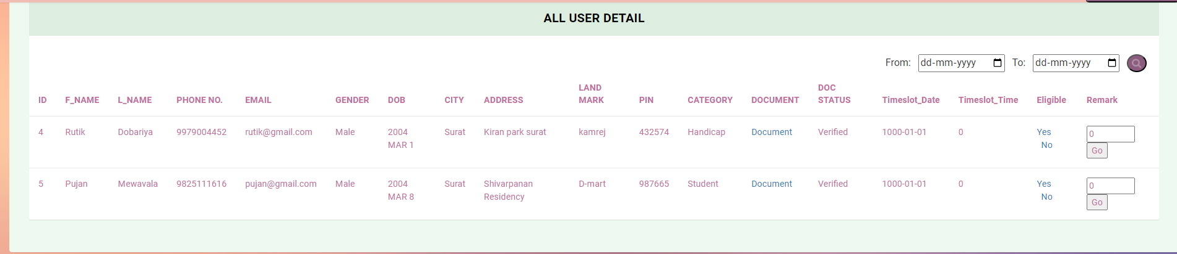

**Verifier can make user Eligible for Buss Pass**

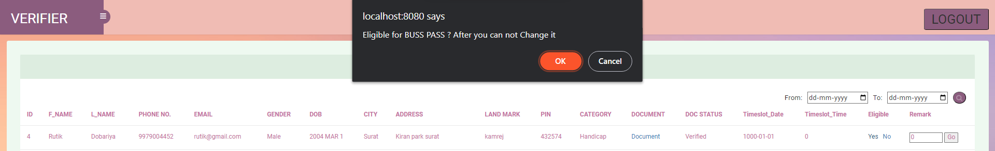

**Log Out**

**Chapter-6**

**Testing**

**6.1 FUNCTIONAL TESTING TEST CASES**

* **TEST CASE FOR USER SIDE**

|  |  |  |  |  |
| --- | --- | --- | --- | --- |
| **Sr.**  **No.** | **DESCRIPTION** | **TEST DATA** | **EXPECTED DATA** | **ACTUAL DATA** |
| 1. | User login, Verify if a user will be able to login with valid username and valid password. | Username:  name  Password:  ********* | Login successful & Home Page is displayed. | Login successful & Home Page is display with login successful toast. |
| 2. | User login,  Verify the login page for both when the field is blank and Login button is clicked. | Username:  BLANK  Password:  BLANK | Login not successful with Snack Bar and show set error with message ‘Fields Cannot Be Empty’. | Login not successful with Snack Bar and show set error with message ‘Fields Cannot Be Empty’. |
| 3. | User login,  Invalid username or password. | Username:  imUser  Password:  ****** | Set Error and Snack Bar message display, Invalid username or password | Set Error and Snack Bar message display, Invalid username or password |
| 4. | User forget password,  If user click on the forget password, and user enters valid username. | Username:  name | Validates if username exists or not if exists then OTP is sent or gives Snack Bar of Invalid username. | Validates if username exists or not if exists then OTP is sent or gives Snack Bar of Invalid username. |
| 5. | User forget password,  If user enters correct OTP | Click on Verify Button | Open up reset password module. | Open up reset password module. |
| 6. | User forget password,  If user enters incorrect OTP | Click on Verify Button | Error Snack Bar with message Enter Valid OTP. | Error Snack Bar with message Enter Valid OTP. |
| 7. | User reset password,  If User enter same password and confirm password | Password:  abc@1234  Confirm Password:  abc@1234 | Closes the reset password module and Success Toast with message ‘Password Updated Successfully’ and redirect to login page. | Closes the reset password module and Success Toast with message ‘Password Updated Successfully’ and redirect to login page. |
| 8. | User reset password,  If User enter different password and confirm password | Password:  abc@1234  Confirm Password:  abc@4321 | Snack Bar error with message ‘Password Must Be Same’. | Snack Bar error with message ‘Password Must Be Same’. |
| 9. | User Sign up,  If User is new to app and doesn’t have account and sign up successful. | Username,  Password,  Confirm Password,  Email,  First Name, Last Name,  Phone Number,  Gender,  Date Of Birth,  Landmark,  Address,  City,  Pin Code,  Category  All Details:  FILLED | Toast display with message ‘Registered Successful’ and redirect to login page to login again. | Toast display with message ‘Registered Successful’ and redirect to login page to login again. |
| 10. | User Sign up,  If User is new to app and doesn’t have account and click on sign up with Empty Fields, | All Details:  BLANK | Sign up not successful with Snack Bar and show set error with message ‘Fields Cannot Be Empty’. | Sign up not successful with Snack Bar and show set error with message ‘Fields Cannot Be Empty’. |
| 11. | User Sign up,  If User is new to app and doesn’t have account and password or confirm password are not same. | Password:  abc@1234  Confirm Password:  abc@4321  All Details :  FILLED | Snack Bar error with message ‘Password Must Be Same’. | Snack Bar error with message ‘Password Must Be Same’. |
| 12. | Status Module, it appears after login successful and where all status are pending, then from navigation drawer user click on My Profile Icon Button. | Click on My Profile Icon Button. | Redirected to My Profile Module. | Redirected to My Profile Module. |
| 13. | Profile Module, User Can See Their Information which they have filled at time of sign up. | Can View All Details of their profile. | View Profile Information. | View Profile Information. |
| 14. | Upload Module, Click on ‘Upload Document’ from navigation drawer and upload all document successfully where user category is ‘Student’. | Aadhar Card:  Uploaded  Electricity Bill: Uploaded  Photo:  Uploaded  Signature:  Uploaded  Bonafide: Uploaded | Toast with Message ‘Document Uploaded Successfully’ and upload document option disables from navigation drawer and Redirected to status module and status of Upload Document Becomes ‘Done’. | Toast with Message ‘Document Uploaded Successfully’ and Redirected to status module and status of Upload Document Becomes ‘Done’. |
| 15. | Upload Module, upload all document successfully where user category is ‘Handicap’. | Aadhar Card:  Uploaded  Electricity Bill: Uploaded  Photo:  Uploaded  Signature:  Uploaded  Disability Certificate: Uploaded | Toast with Message ‘Document Uploaded Successfully’ and upload document option disables from navigation drawer and Redirected to status module and status of Upload Document Becomes ‘Done’. | Toast with Message ‘Document Uploaded Successfully’ and Redirected to status module and status of Upload Document Becomes ‘Done’. |
| 16. | Upload Module, upload all document successfully where user category is ‘Citizen’ or ‘Senior Citizen’. | Aadhar Card:  Uploaded  Electricity Bill: Uploaded  Photo:  Uploaded  Signature:  Uploaded | Toast with Message ‘Document Uploaded Successfully’ and upload document option disables from navigation drawer and Redirected to status module and status of Upload Document Becomes ‘Done’. | Toast with Message ‘Document Uploaded Successfully’ and Redirected to status module and status of Upload Document Becomes ‘Done’. |
| 17. | Upload Module, click on Upload Document without uploading document where category is ‘Student’ or ‘Handicap’ or ‘Citizen’ or ‘Senior Citizen’. | All Documents or any of these all documents are not uploaded. | Error Snack Bar is shown with message ‘Upload Documents First’. | Error Snack Bar is shown with message ‘Upload Documents First’. |
| 18. | Upload Module, click on Upload Document but the document/s size is more than 2MB where category is ‘Student’ or ‘Handicap’ or ‘Citizen’ or ‘Senior Citizen’. | All Documents or any of these all documents size is more than 2MB. | Error Snack Bar is shown with message ‘Size should be less than 2MB’. | Error Snack Bar is shown with message ‘Size should be less than 2MB’. |
| 19. | Upload Module, click on Upload Document but the document/s extension is other than ‘pdf’ where category is ‘Student’ or ‘Handicap’ or ‘Citizen’ or ‘Senior Citizen’. | All Documents or any of these all documents extension is not ‘pdf’. | Error Snack Bar is shown with message ‘Only PDF file is allowed to upload’. | Error Snack Bar is shown with message ‘Only PDF file is allowed to upload’. |
| 20. | Status Module, Admin Verifies user document in online mode. | Admin Verified document uploaded by user. | Status of  Document Verification Becomes ‘Done’. | Status of  Document Verification Becomes ‘Done’. |
| 21. | Slot Booking Module, after Admin Verifies Document Click on ‘Slot Booking’ from navigation drawer and select slot for offline verification. | Select Date:  05-28-2023  Select Time:  4PM – 5PM | Toast with Message ‘Slot Booked Successfully’ and slot booking option disables from navigation drawer and Redirected to status module and status of Slot Booking Becomes ‘Done’. | Toast with Message ‘Slot Booked Successfully’ and slot booking option disables from navigation drawer and Redirected to status module and status of Slot Booking Becomes ‘Done’. |
| 22. | Slot Booking Module, click on slot booking but the fields are not selected. | Select Date:  BLANK  Select Time:  BLANK | Error Snack Bar is shown with message ‘Select Slot First’. | Error Snack Bar is shown with message ‘Select Slot First’. |
| 23. | Slot Booking Module, click on slot booking but the selected date is already passed. | Selected date is already passed | Error Snack Bar is shown with message ‘Date You Selected is already passed’. | Error Snack Bar is shown with message ‘Date You Selected is already passed’. |
| 24. | Slot Booking Module, click on slot booking but the selected date and time slot is already full. | Select date and time where slot is already full. | Error Snack Bar is shown with message ‘The Slot you are trying to book is full.’. | Error Snack Bar is shown with message ‘The Slot you are trying to book is full.’. |
| 25. | Status Module, Verifier Verifies user document in offline mode. | Verifier Verifies user document and check if user eligible for bus pass or not. | Status of  Offline Verification and Bus Pass Eligibility Becomes ‘Done’. | Status of  Offline Verification and Bus Pass Eligibility Becomes ‘Done’. |
| 26. | Status Module, Admin creates bus pass for particular user. | Click on Bus Pass from navigation bar. | User can see bus pass from the navigation bar option. | User can see bus pass from the navigation bar option. |
| 27. | Bus Pass Module,  User Can see and use Bus Pass virtually put can’t see screenshot. | Click on Bus Pass from navigation bar. | User can see bus pass from the navigation bar option. | User can see bus pass from the navigation bar option. |
| 28. | Contact Us Module,  Click on ‘Contact Us’ from Navigation Drawer and click on ‘**brtsbuspass**  **developer@**  **gmail.com**’. | Click on ‘**brtsbuspass**  **developer@**  **gmail.com**’. | User is redirected to gmail and in ‘**From**’ section brts email is written and in ‘**To**’ section write your email to send e-mail to brts developers. | User is redirected to gmail and in ‘**From**’ section brts email is written and in ‘**To**’ section write your email to send e-mail to brts developers. |
| 29. | Contact Us Module,  Click on ‘Contact Us’ from Navigation Drawer and click on ‘**1800-233-0233**’. | Click on ‘1**800-233-0233’**. | User is redirected to phone call and dial this ‘**1800-233-0233**’ number. | User is redirected to phone call and dial this ‘**1800-233-0233**’ number. |
| 30. | Contact Us Module,  Click on ‘Contact Us’ from Navigation Drawer and click on ‘**ADDRESS**’. | Click on ‘**ADDRESS**’. | User is redirected to maps and location of BRTS SURAT OFFICE is set. | User is redirected to maps and location of BRTS SURAT OFFICE is set. |
| 31. | Contact Us Module,  Click on ‘Contact Us’ from Navigation Drawer and click on ‘**INSTAGRAM ICON**’. | Click on ‘**INSTAGR**  **-AM ICON**’. | User is redirected to **INSTAGRAM** page of BRTS SURAT. | User is redirected to **INSTAGRAM** page of BRTS SURAT. |
| 32. | Contact Us Module,  Click on ‘Contact Us’ from Navigation Drawer and click on ‘**FACEBOOK ICON**’. | Click on ‘**FACE-**  **BOOK ICON**’. | User is redirected to **FACEBOOK** page of BRTS SURAT. | User is redirected to **FACEBOOK** page of BRTS SURAT. |
| 33. | Contact Us Module,  Click on ‘Contact Us’ from Navigation Drawer and click on ‘**WHATSAPP ICON**’. | Click on ‘**WHATS-**  **APP ICON**’. | User is redirected to **WHATAPP** group of BRTS SURAT. | User is redirected to **WHATSAPP** group of BRTS SURAT. |
| 34. | Log Out Module,  Click on ‘Log Out’ from navigation drawer and the click on ‘Yes’. | Click on ‘Yes’. | User is logout and redirected to log in page. | User is logout and redirected to log in page. |
| 35. | Log Out Module,  Click on ‘Log Out’ from navigation drawer and the click on ‘No’. | Click on ‘No’. | User is not logout and still remains Log inside the application. | User is not logout and still remains Log inside the application. |

**Table 6.1 Test Case For User Side**

* **TEST CASE FOR ADMIN SIDE**

|  |  |  |  |  |
| --- | --- | --- | --- | --- |
| **Sr.**  **No.** | **DESCRIPTION** | **TEST DATA** | **EXPECTED DATA** | **ACTUAL DATA** |
| 1. | Admin login , if admin login with valid username and password . | Username:-  admin  Password:-  ********* | Login successful & Home Page (Dashboard)is displayed. | Login successful & Home Page (Dashboard) is display. |
| 2. | Admin login , if admin login with invalid username and password. | Username :-  Admin1qwe  Password:-  ***** | Display and error message on login screen and can’t go on next page. | Login not successful and Display and error message on login screen and can’t go on next page. |
| 3. | Admin Dashboard , Admin can view about is work’s Dynamic data. | As per user registered , and how many verifier etc. | Data is view and changing Dynamically as par work. | Data is view and changing Dynamically as per work. |
| 4. | On Admin Dashboard  Admin view a user , verifier and status. | on navbar menu item display | In navbar menu item display successfully | In navbar menu item display successfully |
| 5. | On click on user the sub nav bar menu item Display. | On click on menu item user. | On click the sub menu item are display.(like all user data , Document verified user data , Document pending user data.. etc) | On click the sub menu item are display.(like all user data , Document verified user data , Document pending user data..etc) |
| 6. | Admin click on the All user data . | On click on All user data | Display all user data. In detail like username, first name, last name, mobile no, gender, address, pin code, Category, Doc status. | Display all user data. In detail like username, first name, last name, mobile no, gender, address, pin code, Category, Doc status. |
| 7. | Admin All user Data page, on click one option menu for filtering. | On click on option menu. | On click option menu open and display menu user category (student, handicap, citizen, senior citizen). | On click option menu open and display menu user category (student, handicap, citizen, senior citizen). |
| 8. | Admin All user Data page, in option menu click on student. | On click on student in option menu for filtering. | All user data are filtered in Student user data from all user data. | All user data are filtered in Student user data from all user data. |
| 9. | Admin All user Data page, in option menu click on Handicap. | On click on Handicap in option menu for filtering. | All user data are filtered in Handicap user data from all user data. | All user data are filtered in Handicap user data from all user data. |
| 10. | Admin All user Data page, in option menu click on citizen. | On click on citizen in option menu for filtering. | All user data are filtered in citizen user data from all user data. | All user data are filtered in citizen user data from all user data. |
| 11. | Admin All user Data page, in option menu click on senior citizen. | On click on senior citizen in option. menu for filtering. | All user data are filtered in senior citizen user data from all user data. | All user data are filtered in senior citizen user data from all user data. |
| 12. | Admin click on Document Verified user. | On click on Document verified user | Display users, only which document are verifier by admin successfully. | Display users, only which document are verifier by admin successfully. |
| 13. | Admin document verified page, option menu for filtering users’ data. | On click on option menu. | On click option menu open and display menu user category (student, handicap, citizen, senior citizen). | On click option menu open and display menu user category (student, handicap, citizen, senior citizen). |
| 14. | Admin Document verified Data page, in option menu click on student. | On click on student in option menu for filtering. | All Verified user data are filtered in Student user data. | All Verified user data are filtered in Student user data. |
| 15 | Admin Document verified page, in option menu click on Handicap. | On click on Handicap in option menu for filtering. | All Verified user data are filtered in Handicap user data. | All Verified user data are filtered in Handicap user data. |
| 16. | Admin Document verified page, in option menu click on citizen. | On click on citizen in option menu for filtering. | All Verified user data are filtered in citizen user data. | All Verified user data are filtered in citizen user data. |
| 17. | Admin Document verified page, in option menu click on senior citizen. | On click on senior citizen in option menu for filtering. | All Verified user data are filtered in senior citizen user data. | All Verified user data are filtered in senior citizen user data. |
| 18. | Admin click on Document Verified pending user. | On click on Document verified pending user | Display users, only which document are verification pending by admin successfully. | Display users, only which document are verifier by admin successfully. |
| 19. | Admin document verified pending user page, option menu for filtering users’ data. | On click on option menu. | On click option menu open and display menu user category (student, handicap, citizen, senior citizen). | On click option menu open and display menu user category (student, handicap, citizen, senior citizen). |
| 20. | Admin Document verified pending user Data page, in option menu click on student. | On click on student in option menu for filtering. | All Verified pending user data are filtered in Student user data. | All Verified pending user data are filtered in Student user data. |
| 21. | Admin Document verified pending user page, in option menu click on Handicap. | On click on Handicap in option menu for filtering. | All Verified pending user data are filtered in Handicap user data. | All Verified pending user data are filtered in Handicap user data. |
| 22. | Admin Document verified pending user page, in option menu click on citizen. | On click on citizen in option menu for filtering. | All Verified pending user data are filtered in citizen user data. | All Verified pending user data are filtered in citizen user data. |
| 23. | Admin Document verified pending user page, in option menu click on senior citizen. | On click on senior citizen in option menu for filtering. | All Verified pending user data are filtered in senior citizen user data. | All Verified pending user data are filtered in senior citizen user data. |
| 24. | Admin click on Eligible for Bus pass. | On click on Eligible for Bus pass | Display users, only which user Eligible for Bus pass. | Display users, only which user Eligible for Bus pass. |
| 25. | Admin Eligible for bus pass page, option menu for filtering users data. | On click on option menu. | On click option menu open and display menu user category (student, handicap, citizen, senior citizen). | On click option menu open and display menu user category (student, handicap, citizen, senior citizen). |
| 26. | Admin Eligible for bus pass page, in option menu click on student. | On click on student in option menu for filtering. | All Eligible for bus pass user data are filtered in Student user data. | All Eligible for bus pass user data are filtered in Student user data. |
| 27. | Eligible for bus pass page, in option menu click on Handicap. | On click on Handicap in option menu for filtering. | All Eligible for bus pass user data are filtered in Handicap user data. | All Eligible for bus pass user data are filtered in Handicap user data. |
| 28. | Admin Eligible for bus pass page, in option menu click on citizen. | On click on citizen in option menu for filtering. | All Eligible for bus pass user data are filtered in citizen user data. | All Eligible for bus pass user data are filtered in citizen user data. |
| 29. | Admin Eligible for bus pass page, in option menu click on senior citizen. | On click on senior citizen in option menu for filtering. | All Eligible for bus pass user data are filtered in senior citizen user data. | All Eligible for bus pass user data are filtered in senior citizen user data. |
| 30. | Admin click on not Eligible for Bus pass. | On click on not Eligible for Bus pass | Display users, only which user not Eligible for Bus pass. | Display users, only which user not Eligible for Bus pass. |
| 31. | Admin not Eligible for bus pass page, option menu for filtering users’ data. | On click on option menu. | On click option menu open and display menu user category (student, handicap, citizen, senior citizen). | On click option menu open and display menu user category (student, handicap, citizen, senior citizen). |
| 32. | Admin not Eligible for bus pass page, in option menu click on student. | On click on student in option menu for filtering. | All not Eligible for bus pass user data are filtered in Student user data. | All not Eligible for bus pass user data are filtered in Student user data. |
| 33. | Admin not Eligible for bus pass page, in option menu click on Handicap. | On click on Handicap in option menu for filtering. | All not Eligible for bus pass user data are filtered in Handicap user data. | All not Eligible for bus pass user data are filtered in Handicap user data. |
| 34. | Admin not Eligible for bus pass page, in option menu click on citizen. | On click on citizen in option menu for filtering. | All not Eligible for bus pass user data are filtered in citizen user data. | All not Eligible for bus pass user data are filtered in citizen user data. |
| 35. | Admin not Eligible for bus pass page, in option menu click on senior citizen. | On click on senior citizen in option menu for filtering. | All not Eligible for bus pass user data are filtered in senior citizen user data. | All not Eligible for bus pass user data are filtered in senior citizen user data. |
| 36. | Admin in any page there is no data. | On page open there is no data. | Display **“There is no data!!”** | Display **“There is no data!!”** |
| 37. | Admin on Document verified pending user page, onclick on Document Button. | On click on document Button. | Display particular user Document name on which user document Button you click Display particular user document as depending on user’s category. | Display particular user Document on which user document Button you click Display particular user document as depending on user’s category. |
| 38. | Admin on Document verified pending user page, onclick on Document Button and user category is Student. | On click on document Button. | Display particular user document name photo, signature, light bill, Aadhar card and bonafide certificate. | Display particular user document name photo, signature, light bill, Aadhar card and bonafide certificate. |
| 39. | Admin on Document verified pending user page, onclick on Document Button and user category is handicap. | On click on document Button. | Display particular user document name photo, signature, light bill, Aadhar card and disability certificate. | Display particular user document name photo, signature, light bill, Aadhar card and disability certificate. |
| 40. | Admin on Document verified pending user page, onclick on Document Button and user category is citizen. | On click on document Button. | Display particular user document name photo, signature, light bill, Aadhar card | Display particular user document name photo, signature, light bill, Aadhar card |
| 41. | Admin on Document verified pending user page, onclick on Document Button and user category is senior citizen. | On click on document Button. | Display particular user document name photo, signature, light bill, Aadhar card | Display particular user document name photo, signature, light bill, Aadhar card |
| 42. | Admin on Document page , on click on view button to view user document. | On click on view button | Admin can view a user document open in new tab and verify it. | Admin can view a user document open in new tab and verify it. |
| 43. | Admin on Document verified pending user page,  On click on yes. If user documents are correct. | On click on yes. | Display alert box for yes or no if yes then that particular user data is added in to Document verified user data. | Display alert box for yes or no if yes then that particular user data is added in to Document verified user data. |
| 44. | Admin on Document verified pending user page,  On click on no. If user documents are not correct. | On click on no, | Display alert box for yes or no if yes then that particular user Document are deleted and return for reupload. | Display alert box for yes or no if yes then that particular user Document are deleted and return for reupload. |
| 45. | Admin on Eligible for bus pass page, click on create button to create user’s bus pass. | On click on create button. | Crate a particular user’s E- bus pass and display to the admin and return to the user | Crate a particular user’s E- bus pass and display to the admin and return to the user |
| 46. | Admin on click on verifier to view verifier data. | On click on verifier. | Display all verifier data with there assigned username password branch etc. | Display all verifier data with there assigned username password branch etc. |
| 47. | Admin on verifier page, on click on add verifier to add verifier officer. | On click on ADD verifier Button, | Display form for enter verifier officer details. | Display form for enter verifier officer details. |
| 48. | Admin on verifier page, on click on edit to edit the verifier data. | On click on edit button. | Display a form with fill data in which admin can edit a data and submit it and return to verifier page. | Display a form with fill data in which admin can edit a data and submit it and return to verifier page. |
| 49. | Admin on verifier page, on click on delete button to delete a particular Verifier officer. | On click on delete button. | Admin display an alert box for conformation with yes/no button on click on yes verifier officer removed. | Admin display an alert box for conformation with yes/no button on click on yes verifier officer removed. |
| 50. | Admin on click on status to view about the status of work. | On click on status. | Display a status of admin work like and total number of users, doc. Verification pending user, eligible for bus pass user etc.  (dynamic data) | Display a status of admin work like and total number of users, doc. Verification pending user, eligible for bus pass user etc. |
| 51. | Admin all page on upper right side logout button for logout from website. | On click on logout button. | Redirect admin to the login page can’t go back and all work is saved. | Redirect admin to the login page can’t go back and all work is saved. |
| 52 | Whole website is session authenticate admin can login with id password. | Try to access the any page from URL. | Display alert box and redirect on login page. | Display alert box and redirect on login page. |

**Table 6.2 Test Case For Admin Side**

* **TEST CASE FOR VERIFIER SIDE**

|  |  |  |  |  |
| --- | --- | --- | --- | --- |
| **Sr.**  **No.** | **DESCRIPTION** | **TEST DATA** | **EXPECTED DATA** | **ACTUAL DATA** |
| 1. | Verifier login, if Verifier login with valid username and password. | Username:-  Verifier  Password:-  ********* | Login successful & Home Page (Dashboard)is displayed. | Login successful & Home Page (Dashboard) is display. |
| 2. | verifier login, if admin login with invalid username and password. | Username :-  Admin1qwe  Password:-  ***** | Display and error message on login screen and can’t go on next page. | Login not successful and Display and error message on login screen and can’t go on next page. |
| 3. | Verifier Dashboard, Verifier can view about is work’s Dynamic data. | As per user registered, and how many verifiers etc. | Data is view and changing Dynamically as par work. | Data is view and changing Dynamically as par work. |
| 4. | On Verifier Dashboard  Verifier view an offline user. | on navbar menu item display | In navbar menu item display successfully | In navbar menu item display successfully |
| 5. | On click on offline user to see offline user data. | On click on offline user. | Display today timeslot’s offline verification user data. | Display today timeslot’s offline verification user data. |
| 6. | Verifier on offline user page, click on date filter to see before or after date’s user details. | Click on sort by date. | Display users’ detail, only which timeslot is filter by verifier officer. | Display users’ detail, only which timeslot is filter by verifier officer. |
| 7. | Verifier on Offline user page, on click on document to compare the document. | On click on document Button. | Display particular user Document name on which user document Button you click Display particular user document as depending on user’s category. | Display particular user Document on which user document Button you click Display particular user document as depending on user’s category. |
| 8. | Verifier on Offline user page, on click on document to compare the document and user category is Student. | On click on document Button. | Display particular user document name photo, signature, light bill, Aadhar card and bonafide certificate. | Display particular user document name photo, signature, light bill, Aadhar card and bonafide certificate. |
| 9. | Verifier on Offline user page, on click on document to compare the document and user category is Handicap. | On click on document Button. | Display particular user document name photo, signature, light bill, Aadhar card and disability certificate. | Display particular user document name photo, signature, light bill, Aadhar card and disability certificate. |
| 10. | Verifier on Offline user page, on click on document to compare the document and user category is citizen. | On click on document Button. | Display particular user document name photo, signature, light bill, Aadhar card | Display particular user document photo, signature, light bill, Aadhar card |
| 11. | Verifier on Offline user page, on click on document to compare the document and user category is senior citizen. | On click on document Button. | Display particular user document name photo, signature, light bill, Aadhar card | Display particular user document name photo, signature, light bill, Aadhar card |
| 12. | Verifier on Document page, on click on view button to view user document. | On click on view button | Admin can view a user document open in new tab and verify it. | Admin can view a user document open in new tab and verify it. |
| 13. | Verifier on offline user page,  On click on yes. If user documents are correct. | On click on yes. | Display alert box for yes or no if yes then that particular user data is added in to eligible user data. | Display alert box for yes or no if yes then that particular user data is added in to eligible user data. |
| 14. | Verifier on offline user page,  On click on no. If user documents are not correct. | On click on no, | Display alert box for yes or no if yes then that particular user adds to not eligible for bus pass. | Display alert box for yes or no if yes then that particular user adds to not eligible for bus pass. |
| 15. | Verifier all page on upper right side logout button for logout from website. | On click on logout button. | Redirect verifier to the login page can’t go back and all work is saved. | Redirect verifier to the login page can’t go back and all work is saved. |
| 16. | Whole website is session authenticate so only verifier can login with id password. | Try to access the any page from URL. | Display alert box and redirect on login page. | Display alert box and redirect on login page. |

**Table 6.3 Test Case For Verifier Side**

**Chapter-7**

**Advantages, Limitations & Future Enhancement**

**ADVANTAGES**

* User doesn’t need to stay in a long queue for getting bus pass, they can easily grab their bus pass by applying for it online.
* Also, admin and verifier doesn’t need to handle the long queue
* User doesn’t need to visit the office persistently for getting the required bus pass instead of user only need to visit once for verification of identity to receive the bus pass by using this application.
* Admin and verifier get relief from burdensome of handling the lengthy process of paper work and documentation.
* User obtain their e-bus pass after the completion of the verification process in this application.

**LIMITATIONS**

* This process is not fully online it needs the user interaction offline once for verification of their identity.
* As increasing user, complexity for an admin increases so we need to appoint multiple admins per branch.
* This application is only applicable to a single city.

**FUTURE ENHANCEMENT**

* There are lots of Future Enhancements in BRTS BUSS PASS ONLINE REGISTRATION APPLICATION.
* Planning of using cross platform for Users, Verifier Officer and Admin is under future scope. In future, Admin can verifier document in Android Application and Verifier can also use Android Application for verification in Identity. User can also apply for bus pass on Web Portal.
* Existing Application serves only to a particular city but in future the planning for the service of this Application will be expanded to a Nation or an International level.

**Chapter-8**

**Conclusion**

**CONCLUSION**

From this BRTS BUSS PASS ONLINE REGISTRATION APPLICATION we can conclude that User can easily get their Bus Pass by applying in online mode by BRTS BUSS PASS ONLINE REGISTRATION APPLICATION without getting trouble of standing in long queue and filling long paper forms.

Admin and Verifier Officer can also easily help user getting their Bus Pass. Admin and Verifier Officer also need not to control the long queue and complexity in managing the paper works in offline mode.

**Bibliography**

* Roger S. Pressman, “Software Engineering: A Practitioner's Approach”, 7E, Tata McGraw Hill.
* Ian Somerville, “Software Engineering”, 9E, Pearson education PHI.
* Rajib Mall, “Rajib Mall”, 4E, PHI.
* Madhulika Jain, “Structured System analysis and Design”, 1E, BPH Publication.
* Michael R Blaha and James R Rambaugh, “Object Oriented Modeling and design with UML”, 2E, Pearson Prentice Hall.
* [www.geeksforgeeks.org/what-is-dfddata-flow-diagram/amp/](http://www.geeksforgeeks.org/what-is-dfddata-flow-diagram/amp/)
* <https://www.google.com/amp/s/www.geeksforgeeks.org/how-to-write-a-good-srs-for-your-project/amp/>
* Project Scope Definition (tutorialspoint.com).